**City University of Hong Kong**

**School of Continuing and Professional Education**

**PROGRAMME - {173-19431}**

**BSc (Hons) Information Technology for Business (3-yr Full Degree)**

**Coventry University**

**ALL Project 2**

**Group 8**

**Name: LAI Tiffany Hoi Jun, LAM Yat Fung, LI Yat Long, MA Kwan Yat**

**Student ID: 55201151, 55202135, 55201950, 55201114**

Table of Contents

Company Overview / Target Customers Overview 4

Proposed application overview 4

Service Catalog 5

Blueprint 6

Service Level Agreement (SLA) 7

MkyStore As-is 13

MkyStore To-be 15

MkyStore website To-be 17

Cost Benefit analysis 19

Introduction (104KM) 21

ER diagram 21

Database diagram 22

Use case diagram 23

Class diagram 24

Activity diagram 26

Sequence Diagram 29

Introduction to GUI POS System 30

How to use the system 31

Introduction 31

Add product 32

Delete product 33

Membership 33

Payment by cash 34

Update product 35

Add product 36

Delete product 37

Cash In Machine 37

Report and Reset 38

Z report 38

Bar chart 39

Logout 39

Testing 39

login 39

Payment by cash 40

Update product information in database 46

Add new product to database 49

Delete product data in database 51

Cash in machine 52

Buttons 55

Logout 57

Limitation of our POS system 57

Introduction to The Website 58

How to use the Website 58

Searching and Comparing 58

Logon Page 59

Register Page 59

Personal information 60

Alter information 60

Website Testing 61

Register 61

logon 64

Alteration 66

Searching 68

Limitation of our website 69

List of Reference 70

# 

# Company Overview / Target Customers Overview

The ‘MkyStore’ is a small convenience store similarly to the provision store or concession stand selling products like food and drink.

The computer POS system has not been installed for their business before, the only equipment they owned are a simple calculator, some notebooks to record the inventory information, pens, a box to store the money, a booklet of receipts and few computers for the staff to save the information written in notebooks to digital form.

Every time a customer would like to buy a product, the staff would calculate the total price at least twice to ensure no mistake is made and invoice are presented in hand written format. Although the staff rechecked the bill, error still exist and find every day. Besides, the payment progress is extremely slower than other competitors. Therefore, many customers refuse to shop in MkyStore if they are in hurry and the customer satisfaction are lower than other similar shops.

After the implementation of the POS system, the situation improved significantly. Every time customer would like buy product, the staff could input product code into the system so that the system will calculate the total price automatically and result of what have been counted will be shown. Thus, the staff confirm the calculations easier and decrease the chance of calculation mistake. Furthermore, the system also provides other useful features such as inventory counting. After the products is counted as sold in the system, the inventory value will also change, which allow the staff to know the inventory information more clearly. Besides, other features such as search or report also allow the staff understand the situation of the store more. The implementation of POS system can highly increase the efficiency of the shop and increase the customer satisfaction.

Last but not least, this POS system is available for all the staff use in the MkyStore. It is believed that a uplifting changes will see after the implementation of the system.

# Proposed application overview

Our team is going to design and develop a POS system for a chosen business which is a new founded small convenience store called ‘MkyStore’.

Nowadays, point of sale (POS) system is important and necessary for a store including convenience store and supermarket because it makes positive effects in calculation, searching or management for the business.

We believe that the system can benefit ‘MkyStore’ in competitiveness, marketing, efficiency, process improvement, value for its customer and business intelligence these six areas.

There are total 8 functions in our POS system: staff login, payment calculations, searching products, daily reports generation, bar chart generation, invoice printing, modify product data and reports printing.

# Service Catalog

|  |  |
| --- | --- |
| Element | Description |
| Service | POS System |
| Status | LIVE |
| Description | A system for convenience stores daily use. |
| Standard Service Features | A system that can calculate the payments in store automatically with simple input. The users can make use of the serval functions like searching the products, generating sales record, modify the products data and printing the receipt and report in order to have higher working efficiency. |
| Optional Service Features | Generate weekly report  Update membership record |
| Delivery Scope | The system will be available in all stores. |
| Delivery Channels | Computers (desktop) which install POS system. |
| Service Hours | 24/7/365 |
| User Requirements | The staff in mkyStore are available to use the POS system. |
| Service Initiation | The staff register the account (username and password) to login the system first. Then, prepare the database to store products, staff and customer data. |
| Standard Support | Telephone support |
| Standard Costs | Initial infrastructure set up: Medium  computer x2 + printer for printing receipt/ z report x2 + colour print toners x2 + server + labour staff(IT department) x3  =$(20 000 x2 + 410 x2+ 320 x2 + 3390 + 30 000 x 3)  =$134 850  Running costs: Low  electricity + repair and maintenance  =$(39 200 + 800)  =$40 000  Customer costs: None |
| Optional Costs | Barcode printer (around $1 500 – 2 500)  Barcode scanner ($800 – 1200) |
| Service Targets | The system must available in 24 hours and maintain every 3 months. In addition, the expected downtime is 2 working days during the maintenance in every 3 months. |

# Blueprint

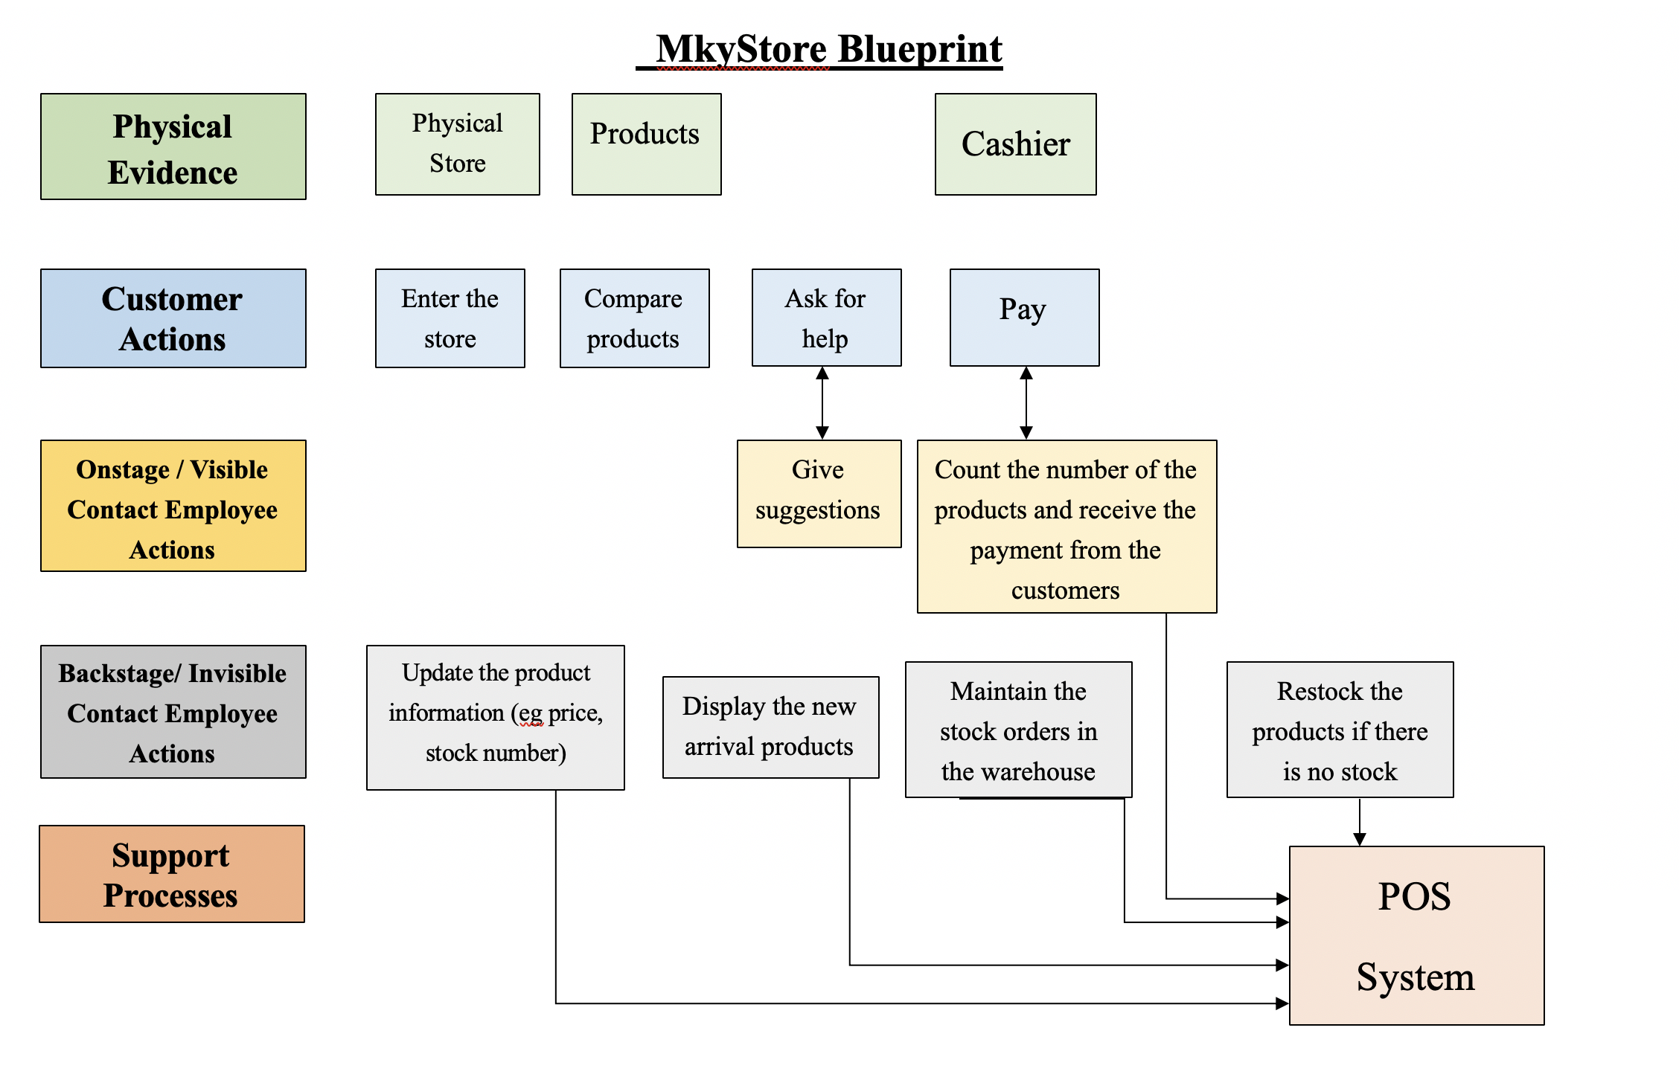

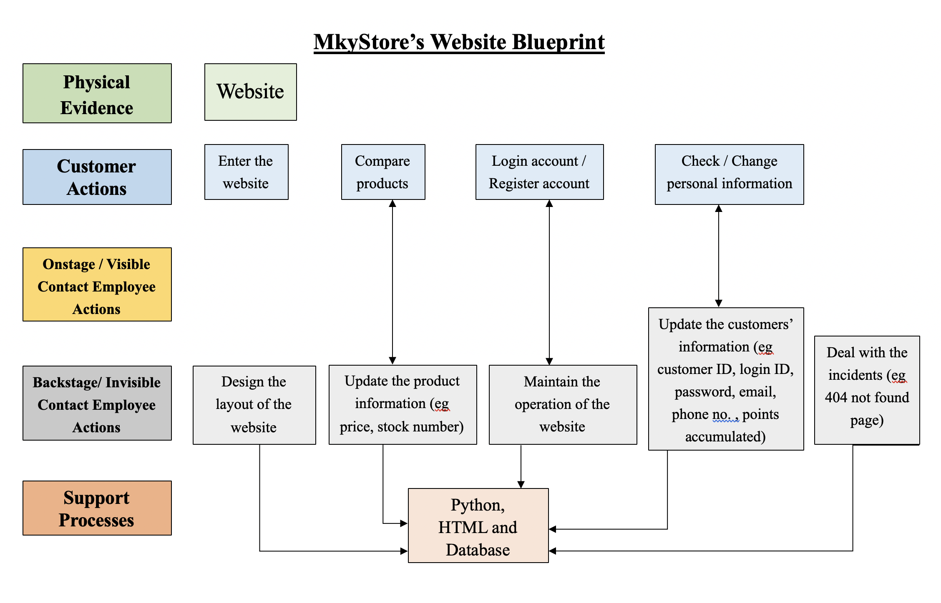

Service Level Agreement (SLA) 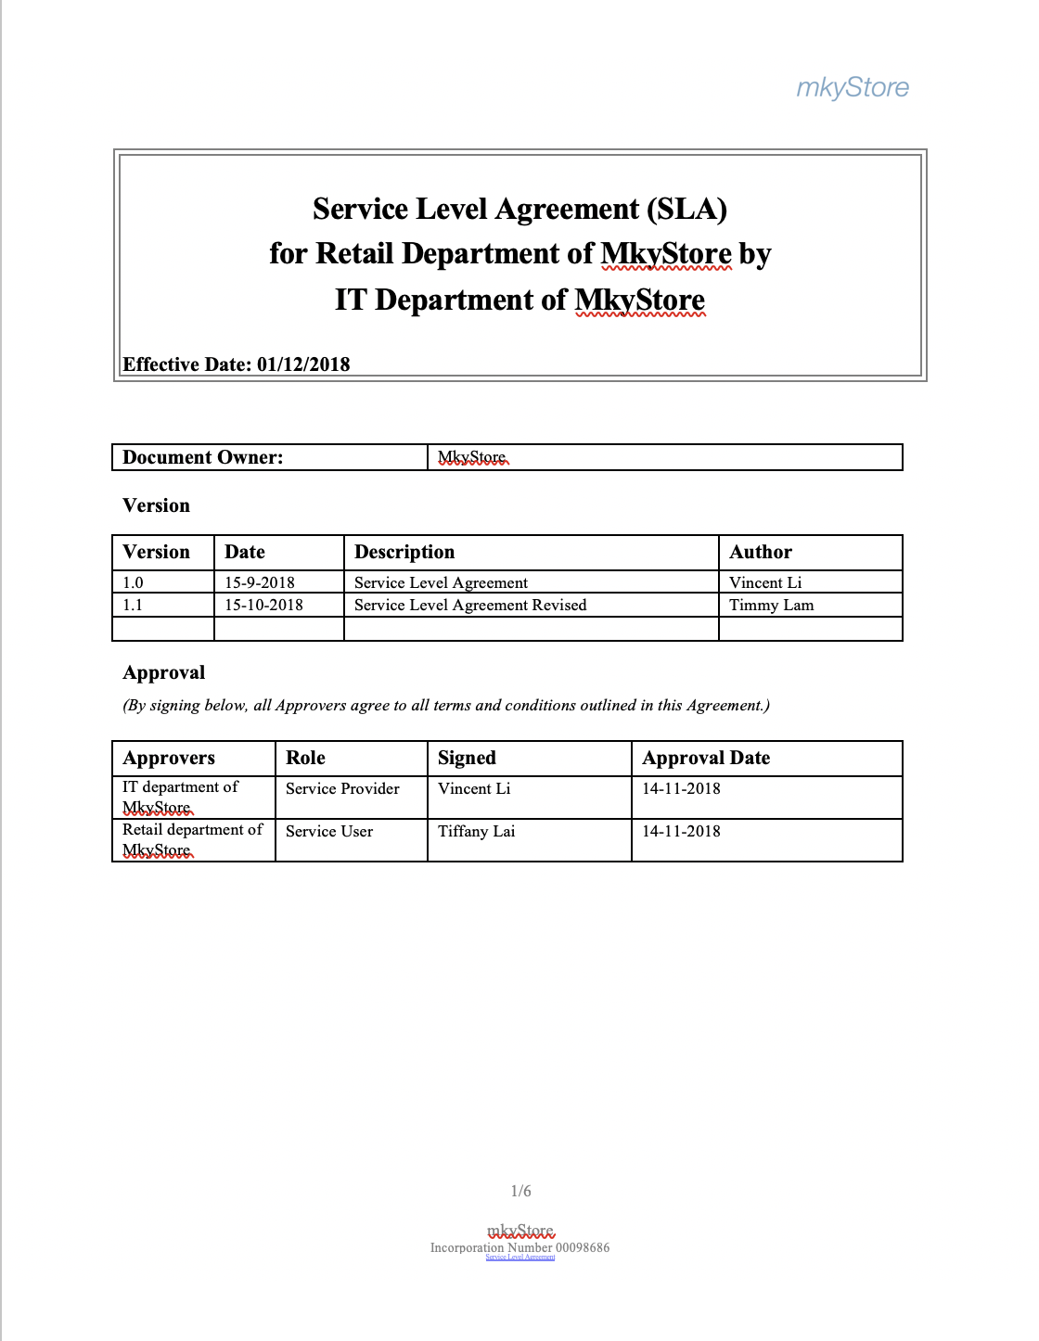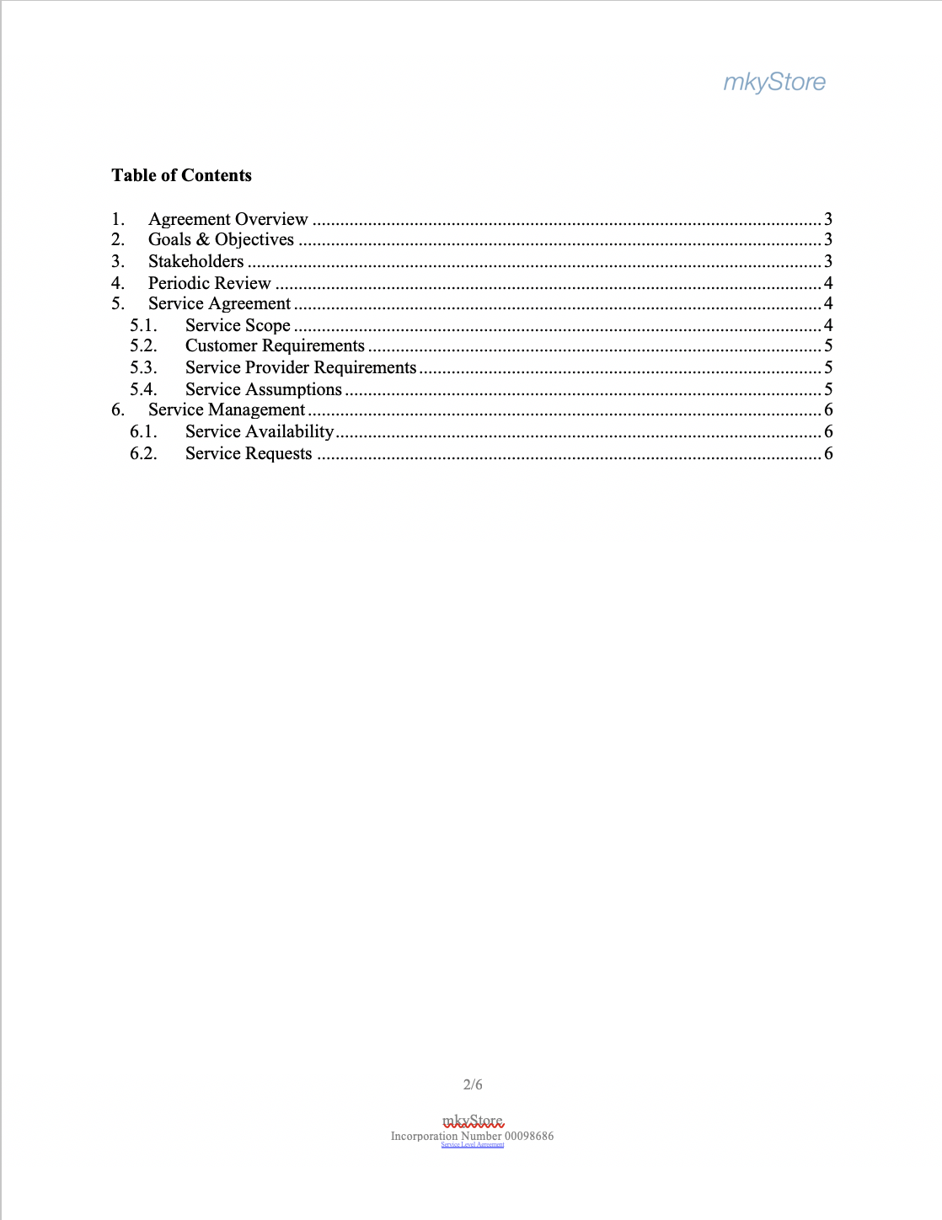

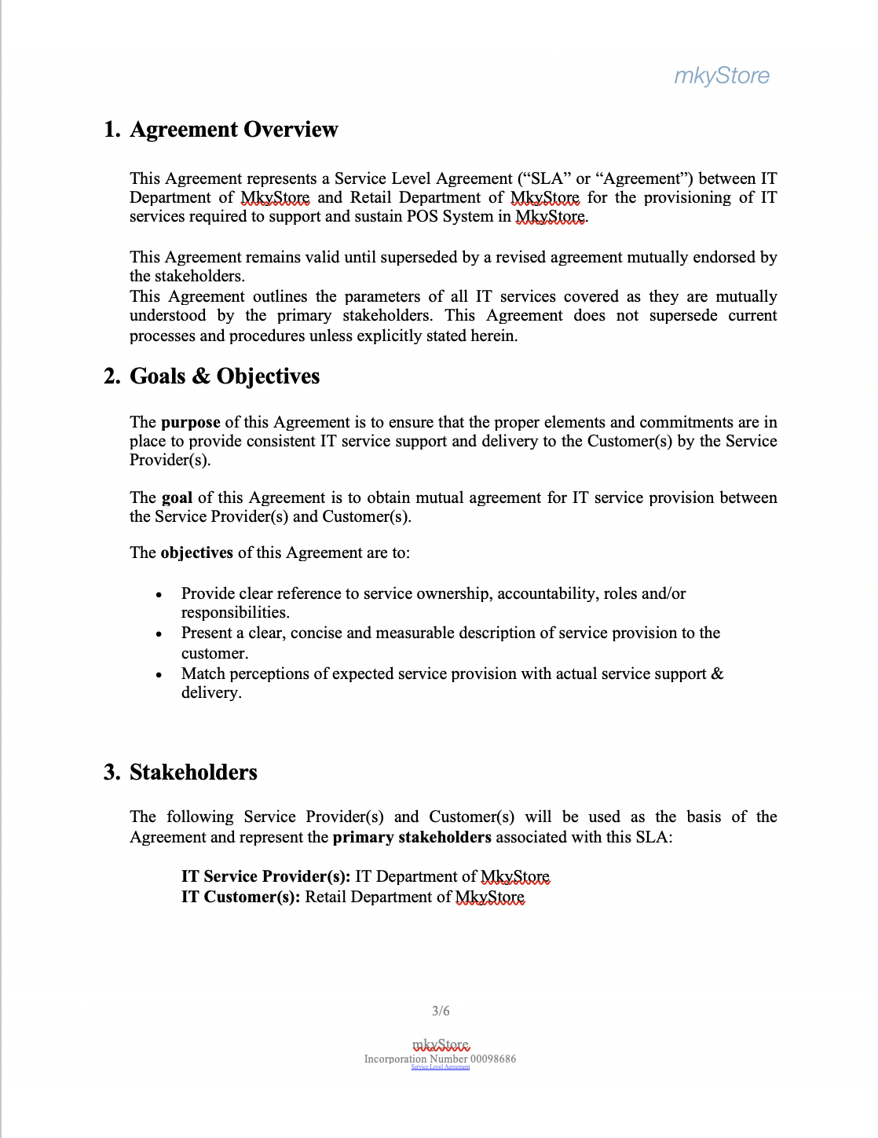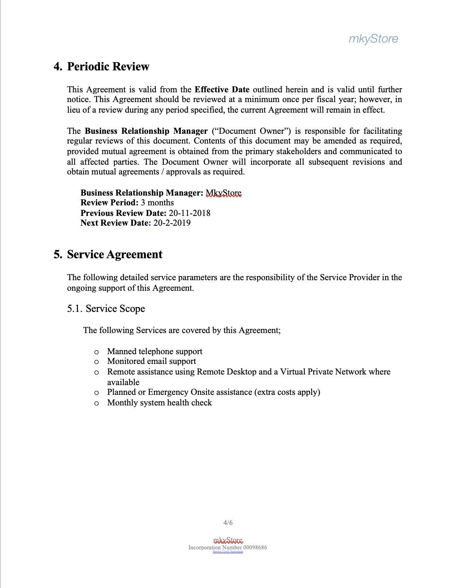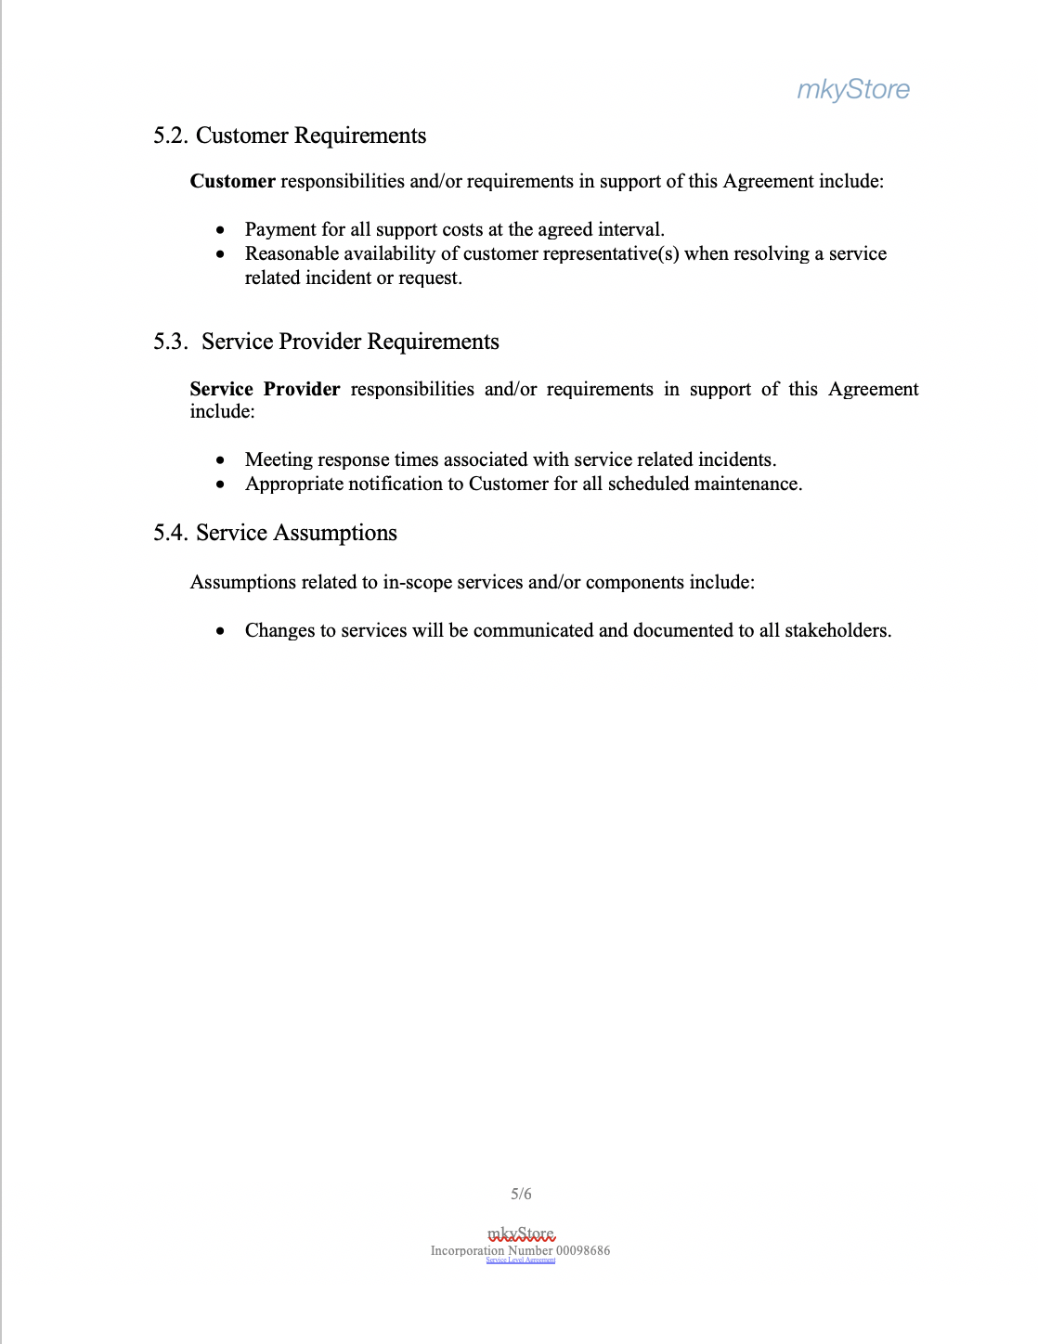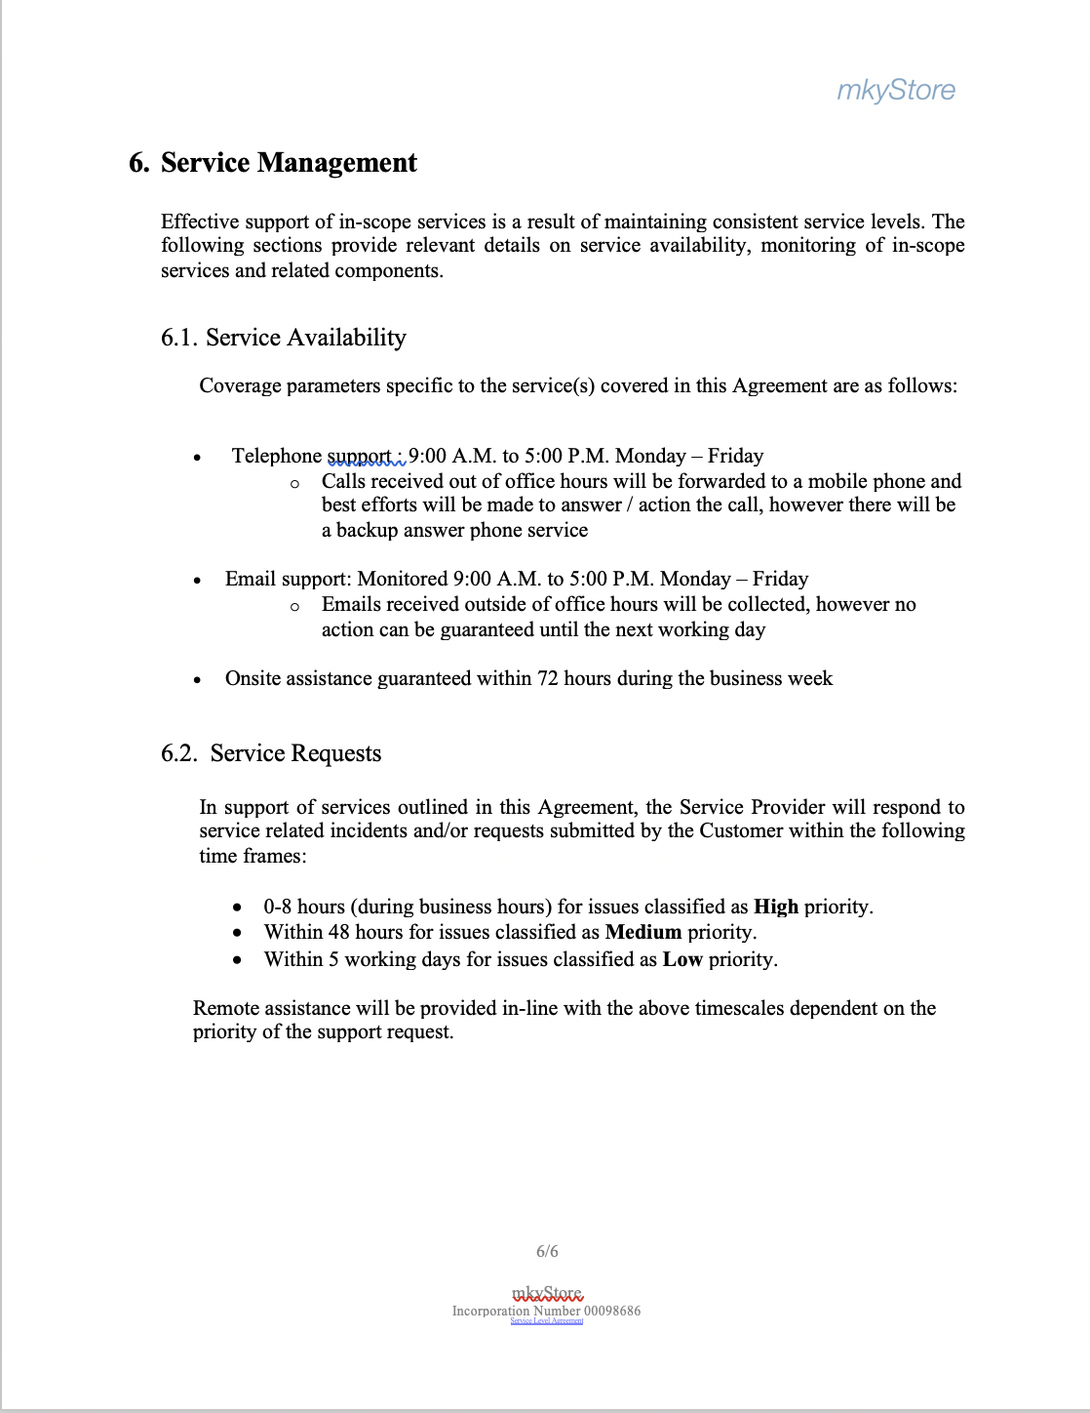

# MkyStore As-is

|  |  |  |  |  |
| --- | --- | --- | --- | --- |
|  | Step | Processing time | Wait time | Remarks |
| A | Staff have to do basic preparation  before starting daily operation. | 30 mins | 10 mins | The staff have to count the quantities of goods and prepare the those basic equipment before start operating the convenience store. A simple calculator to ensure the correct sales amount, some notebooks to record the change of inventory and goods information, stationery, a box to store the money and a booklet of receipts. |
| B1 | The staff write down the product information on the sales booklet for  customer’s purchase. | 10 mins | 5 mins | The staff should write down all the information of the product that customer purchased, including the product name, brand, price, quantities and the total amount. |
| B2 | The staff search the product by walking around. | 15 mins | 15 mins | When the customers ask the staff where the product is or whether there is enough of  product in store, the staff have to walk around in store to search and look for the products. |
| C | The staff have to write the receipt if the customers required. | 5 mins | 3 mins | If the customer request to give receipt, the staff have to write the official  receipt by themselves and sign or chop the store name. |
| D | Recording the sales transition for the day after the business hours. And calculate the sales of the days. | 30 mins | 15 mins | After the business hours, the staff should record and calculate the daily income and sales, and record it in the sales booklet. |

Total processing time = 90 mins

Total waiting time = 48 mins

|  |
| --- |
| https://lh3.googleusercontent.com/UNleEtDNIoqMubrPRbDxodH1HsSCGUGDAM_ELsrjrbZnqZmKGfKUx1PN-TSFVn5SEo-Z_0E5iQ79lLi-RQOsgPWZBHBmLjLloBdeyymmPOUgJfwiNux8gjaMv8NQw2YObs196g4k |

# MkyStore To-be

|  |  |  |  |  |
| --- | --- | --- | --- | --- |
|  | Step | Processing time | wait time | Remarks |
| A | The staff turn on device, Login the system by the staff and input the initial cash in that casher counter | 2 mins | 5 mins | The staff has to put up the computer and login the system by inputting their staff account and password.  Moreover, amount of cash should be inputted |
| B1 | The staff enters the product code for customer’s purchase and payment | 3 mins  (depends on how many products need to be inputted) | 2 seconds | The staff has to enter the product code to record the sales of each customer. If the customer provide their membership (phone number), the system will calculate the discounted amount that the customer should pay (if the customer own enough points) and record the gaining points of the member. |
| B2 | The staff can search the product information | 10 seconds | 2 seconds | staff can search product information and storage by product ID. |
| C | The staff can print the receipt for each payment and refund. | 2 seconds | 15 seconds  (depends on how many products need to be printed) | For each payment and refund process, a receipt should be generate. |
| D | The staff can change the quantity of product in the system. | 3 mins | 2 seconds | The staff can update the quantity of products themselves. Although the system will auto update the quantity record, the staff still update the record due to loss. |
| E | Generate the sales bar chat | 5 mins | 3 seconds | The system will generate the sales bar chart to show the sales performance of each product category for the day . |
| F | Input the amount of cash when closed and Print the Z report | 1 min | 5 mins | Input the amount of cash and Z report should be print out to show the record and daily performance of the convenience store. |
| G | The staff or manager should logout the system at the end of the day. | 1 min | 5 mins | The staff should logout the system at the end of each day to ensure  high security of the POS system. |
| Total processing time = 15.2 mins  Total waiting time = 15.4 mins | | | | |
|  | | | | |

# MkyStore website To-be

|  |  |  |  |  |
| --- | --- | --- | --- | --- |
|  | Step | Processing time | Wait time | Remarks |
| A | The customer/staff browse MKY Store’s website | 30 seconds | Around 5 seconds (depends on network speed) | The customer/staff can browse the MKY store’s website on internet by using laptops or smart phones. |
| B | The customer/staff can compare and search product price online. | 2 minutes | Around 5 seconds (depends on network speed) | The customer/staff can search by different category, i.e. product name, product types and brand name. |
| C | Customer can registered their customer account of MKY store online. | 5 mins | Around 5 seconds (depends on network speed) | Customer can registered their own customer account with providing some basic information. The account is used for customer to gain membership points or saving discount. |
| D | Customer can login their customer’s account to search/ change their personal information. | 30 seconds | Around 5 seconds (depends on network speed) | The customer can login their own customer’s account. Basic customer information (email, phone no., customer ID, login ID, password and point collected) can be checked/changed on website |

Total processing time = 8 mins

Total waiting time = 0.33 mins or 20 sec

|  |
| --- |
| https://lh5.googleusercontent.com/uaOK2kDypQIIXIwZtejPYL-3joQj0HKjm4HktmkxdPaBgaawoVr0tM1c84uNCM1zULMCMIR_673gBZdSlZdOVuqKp--BwUAiB7oBuNREEx1YoEU6z5tlM9c609YFDALcujLGKyrV |

|  |  |
| --- | --- |
| AS-IS VERSUS TO-BE MAPPING | |
| AS-IS | https://lh5.googleusercontent.com/41hxhLLN_x-Sn-DflXWEYwFq9BETk_D7LEQT3fNY73DA_4c2f5dPZm2emm96KuHWc126X05jBQhYELjFBW7BWG-uGybr3VqoToLMPHGv3eypa2pudYvTvdFen7jTD2L-VKSulWK- |
| TO-BE | https://lh4.googleusercontent.com/DFVZCrXSubv1w6lXFEkqrUcV4A-sIhAX5HN9QpGWnlUMwk6x-kwyDE5oyFXLkxVFKwFRom-d1rBo50ydIsQzMOowrHsg7PQxXQdd6ivigBfEZXgLGnv80kxAa-ye42pdknXS_zkA |

Cost Benefit analysis

1a)

Cost decrease:

* reduced 1 computer

= $(100 000 - 80 000)

= $20 000

* reduced labour cost per staff

= $120000 x [(138-30.6)/60]hours /(30 days x 8 hours )

= $895

total reduced labour cost

= $895 x 20 staff

= $ 17900

* reduced inventory

revenue increase

= $(1 008 000 - 720 000)

= $ 288 000

1b) revenue increase due to the engagement of customer

Gross profit increase

= $( 543 300 - 352 800 )

= $ 190 500

2a)

estimated cost for developing

= computer x2 + printer for printing receipt/ z report x2 + colour print toners x2 + server + labour staff(IT department) x3 + rent and rate + electricity + repair and maintenance

= 20 000 x2 + 410 x2+ 320 x2 + 3390 + 30 000 x 3 + 43 200 + 39 200 + 800

= $218050

2b)

initial cost

= 20 000 x2 + 410 x2+ 320 x2 + 3390 + 30 000 x 3

= $134 850

2c)

running cost

= 43200 + 39 200 + 800

= $83 200

3

payback period

= initial investment / cash flow per period

= 218 050 / 720 000

= 0.303  years (cor to 3 sig fig)

*computer price:

DELL XPS15-9570

* Window 10 Home 64bit English, Simplified Chinese, Traditional Chinese
* 8th Generation Intel®  Core ™ i7-8750H Processor ( 9M Cache, up to 4.1 GHZ, 6 Cores)
* SSD+HD
* 128GB + 1TB HDD
* 15.6" FHD (1920 x 1080) InfinityEdge Anti-Glare Non-touch IPS 100% sRGB 400-Nits display
* NVIDIA® GeForce® GTX 1050Ti with 4GB GDDR5

Financial Management:

* Annual Cost Saving

The processing of counting the quantity of good is reduced because the system will auto-count the stock and report the Sales output per day. The staff do not have to count and record sales in written form and the processing can go through more faster, the efficiency of the convenience store’s Sales will improved. The labour force can be saved and the processing time will also be decreased.

* Increase more customers

The customers can search product and view their customer information online by browsing the website. It will be more convenience for the customers as they do not have to walk-in to the store and ask the staff to search individually. This will attract more customers to purchase in the convenience store as they can search and view goods and information before visiting the store.

# Introduction (104KM)

Our team is going to design and develop a POS system for a chosen business which is a new founded small convenience store called ‘MkyStore’.

Nowadays, point of sale (POS) system is important and necessary for a store including convenience store and supermarket because it can help to calculation, searching or management for the business.

The GUI POS System Include the following features:

* Login by different staff
* Calculate how much customer should pay
* Add, delete, view and update the product information
* Update the points collected of VIPs
* Generate receipts, Z report and bar chart

Also, a website is built to allow customer to check the product information or their membership details such as how many points they have collected and the personal information.

# ER diagram

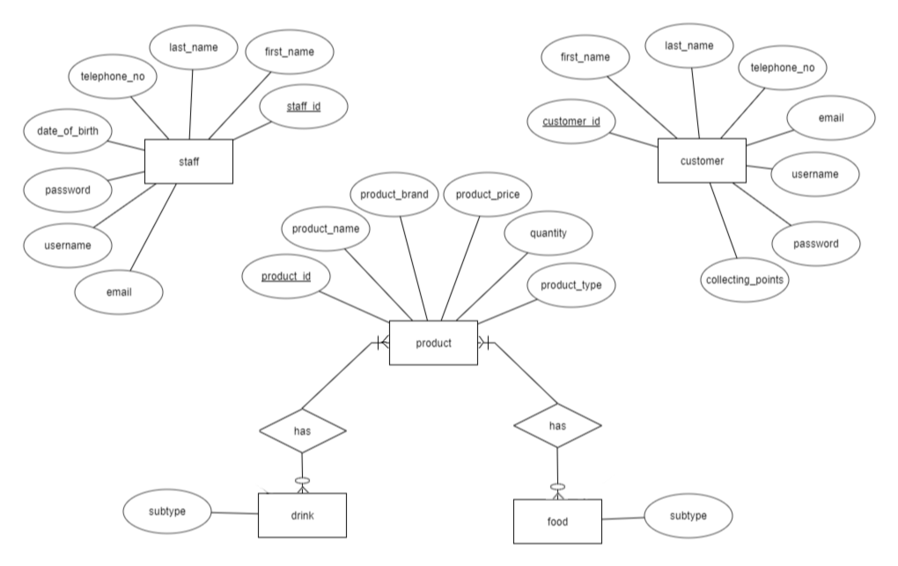

* There are 5 entities of the Store.
* One or more products has zero to more many drinks/foods
* Product own attributes related to product information
* Staff and customer own attributes which is related to staff/customer personal information

# Database diagram

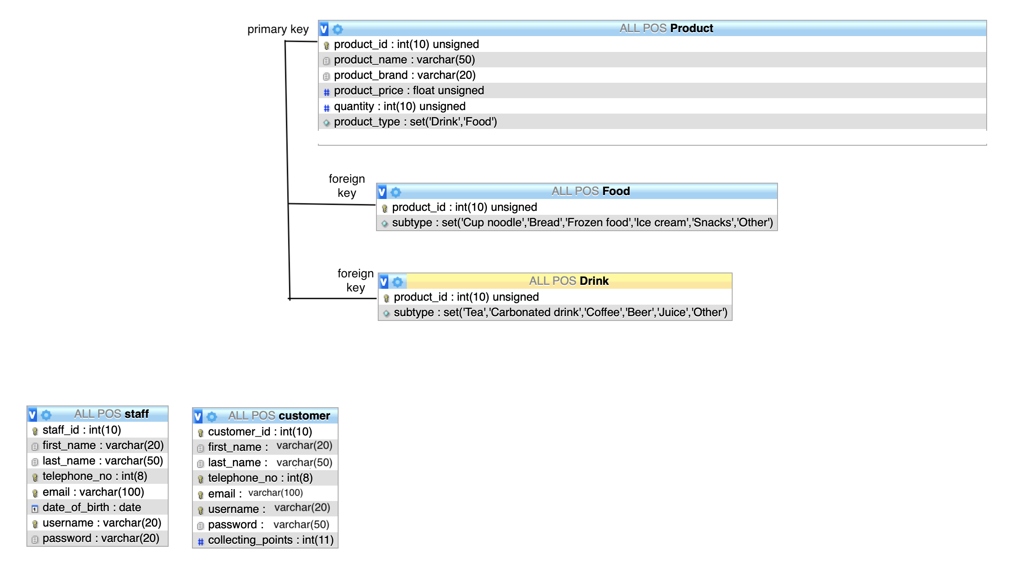

There are three database table in our system, including product, staff and customer.

The product table stores the product information which is necessary for the program and the website to perform the daily tasks.

* primary key: product_id, it should be unique in the table to identify the product.
* Product_name and product_brand are variable character
* Product_price and quantity are integer
* Product_type is a set to select ‘Drink’ or ‘Food’

The Drink and Food table store the identify the subclass of the product

* Product_id is the foreign key
* Subtype is a set to store different type of drink/ food to identify the product

The staff table stores the staff personal information such as their name and the user name and password for login the POS system

* The staff_id is a primary key to identify the staff
* The first_name and last_name are variable character
* Telephone_no is a integer and should be unique to identify the staff
* Email is a variable character and should be unique to identify the staff
* Date_of_birth is in date type
* Username is a unique variable character which is used for staff to login the POS system
* Password is a variable character which staff need to input when login

The customer table stores the customer information which allow the POS system and website to update and check their points collected.

* The customer_id is a primary key to identify the customer
* The first_name and last_name are variable character
* Telephone_no is a integer and should be unique to identify the customer
* Email is a variable character and should be unique to identify the customer
* Username is a unique variable character which is used for customer to login the website
* Password is a variable character which customer need to input when login
* Collecting_points is a integer that stores the points collected of each customer after purchase in our shop

# Use case diagram

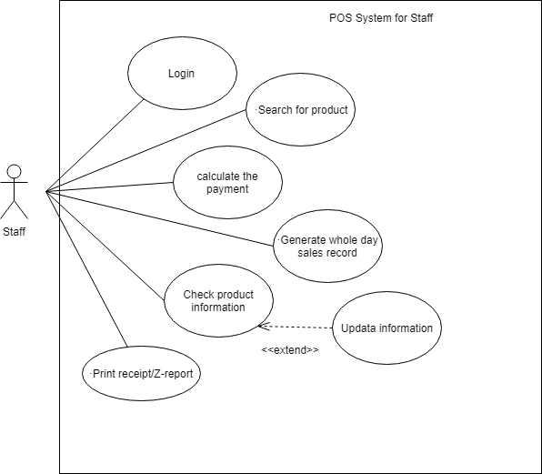

update

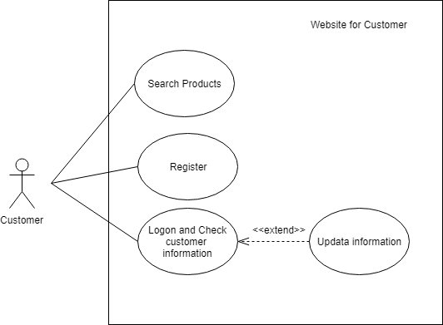

update

# Class diagram

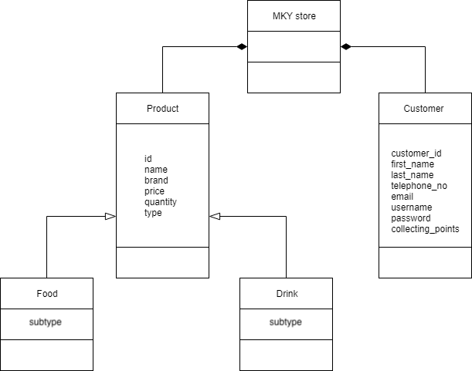

customerID

firstName

lastName

telephoneNo

email

username

password

collectingPoints

*..1

1..*

The above class diagram describes the relationship in MkyStore

* The store has 1 to many products
  + All products share id, name, brand, price, quantity and type as attributes (inheritance)
  + Food own a unique attribute subtype which include the food type such as bread, ice cream and cup noodles.
  + Drink own a unique attribute subtype which include the drink type such as tea, milk and coffee.
* The store has 1 to many customers
  + With customerID, firstName, lastName, telephoneNo, email, username, password and collecting points as attributes.
* Product and customer are a part of MkyStore which cannot exist alone.

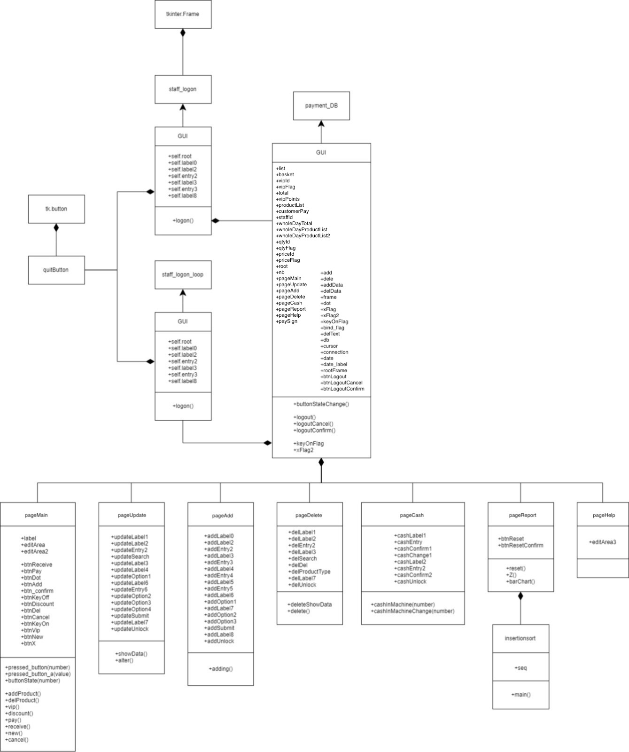

+addDisplay

+showAdd()

+cashNowLabelInitial

+cashNowLabelIThen

+zLabel

This is the class diagram of the POS system

* The GUI class is a part of thinker.frame (composition)
* Quitbutton is a part of two logon program (composition)
* Program payment_DB.py include 7 pages
  + PageMain allow user to calculate how much customer should pay and update database (collecting_points in customer and quantity in product)
  + PageUpdate allow user to update the product data in database
  + PageAdd allow user to add new product data in database
  + PageDelete allow user to delete whole product data in database
  + PageCash allow user to input the amount of cash in the machine on the day start/end
  + PageReport allow user to print Z report, bar chart and reset the system
  + PageHelp tips the user how to use the system
* Class insertion sort is a part of page5

# Activity diagram

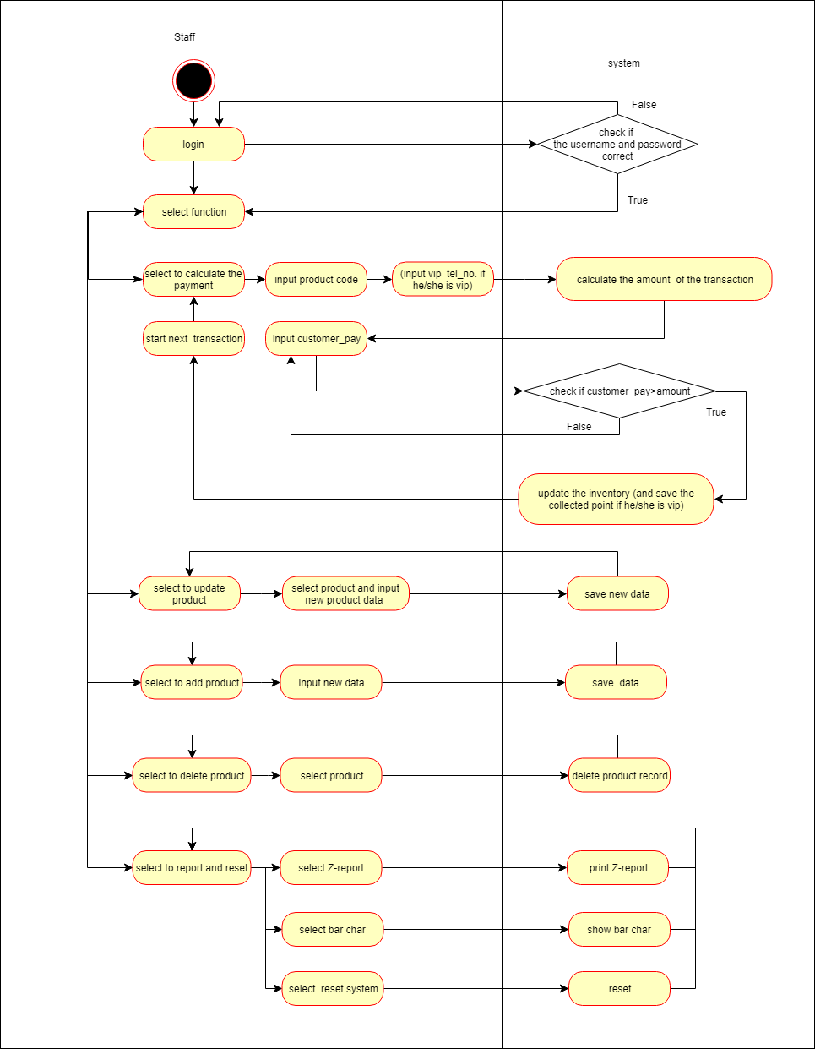

t

And Print receipt

t

The above activity diagram shows how the POS system process.

1. The staff first login to the system
2. Choose function
3. If staff choose calculate payment:
   * + Staff need to input product ID (and VIP telephone number)
     + Calculate how much customer should pay
     + Receive the money from customer
     + Calculate how much should change back to customer
     + Update database table (inventory, points of customer)
     + Store the record of this payment
     + Print receipt
4. If staff choose to update or delete product:
   * + Input product ID
     + Input updated data/ click delete button
5. If staff choose to add product:
   * + Input new product data
6. If staff choose to print report or reset:
   * + Click the button and the system will automatically run

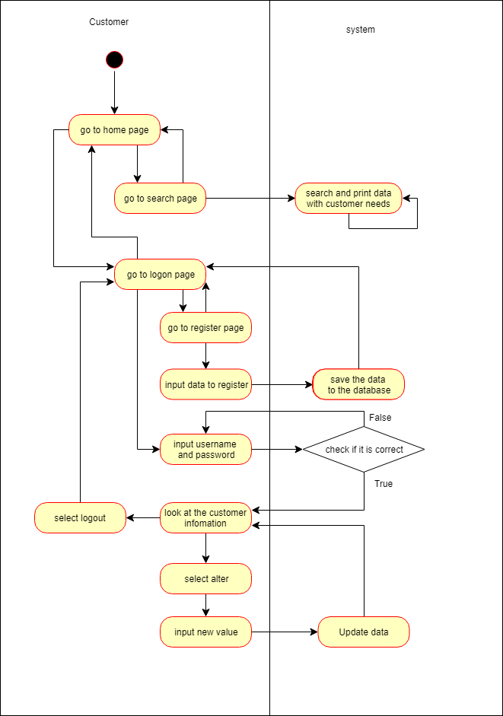

The above activity diagram shows the activity of the website.

1. If the user chooses to search for product
   1. Choose search criteria
   2. System output result
2. If the user clicks the login page
   1. Login
      1. Display the member’s personal information
   2. Register
      1. Input the personal data
      2. Resistor success

# Sequence Diagram

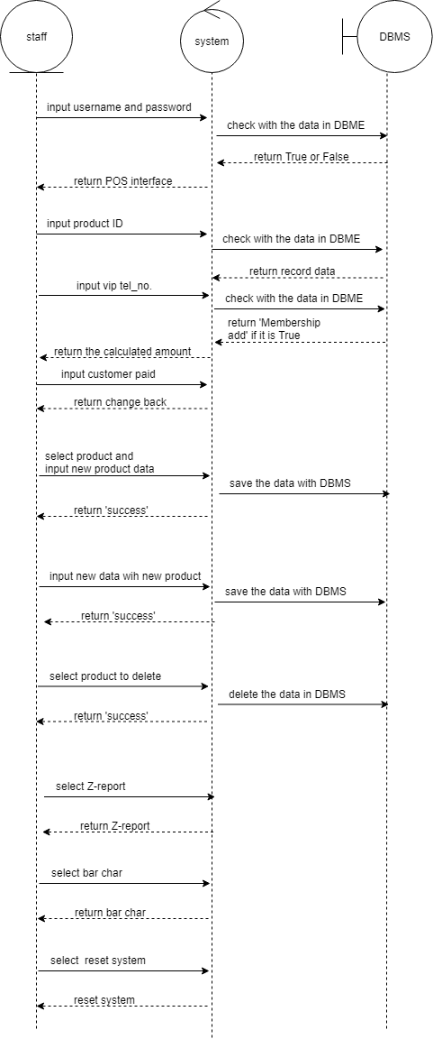

The sequence diagram shows how the staff, POS system and database interact with each other.

* When user login, they will input the information to the system, and the system will request the database to gain the staff login data and compare with the input data
* When adding product to the basket, the data will be updated to the database

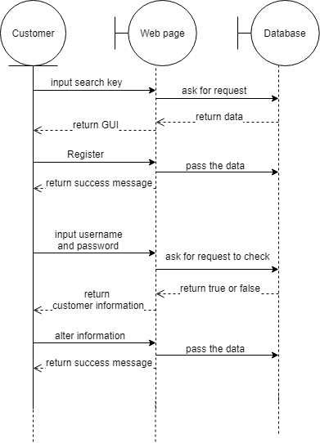

The sequence diagram shows how the customer, website and database interact with each other.

* When user want to search for a product, the web page asks the database to provide the product data and the data will be display on the user computer screen.
* When user want to register, the user will input the data to the website and the website will pass the data to the database to save

# Introduction to GUI POS System

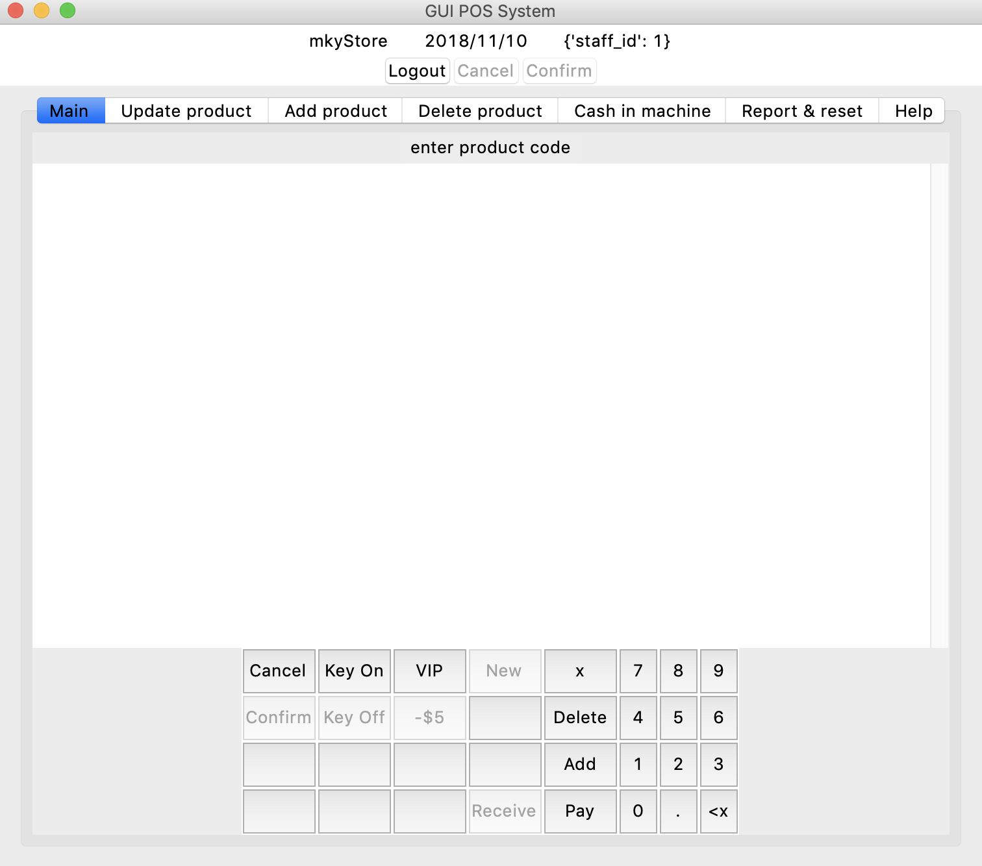

The GUI POS System Include the following features:

* Login by different staff
* Calculate how much customer should pay
* Add, delete, view and update the product information
* Update the points collected of VIPs
* Generate receipts, Z report and bar chart

# How to use the system

## Introduction

To use the system, the user should first turn on the MySQL database and Apache server with 5 databases file (customer.sql, staff.sql, drink.sql, food.sql and Product.sql) imported. Moreover 5 python programs (staff_logon.py, staff_logon_loop.py, payment_DB2.py, quitButton.py and insertionsort.py) and 5 datafiles (z_datasource.txt, deleteReport.txt, Password.txt, cashInMachineNow.txt and cashInMachineInitial.txt) should also be prepared.

After that, the user should open the logon.py file

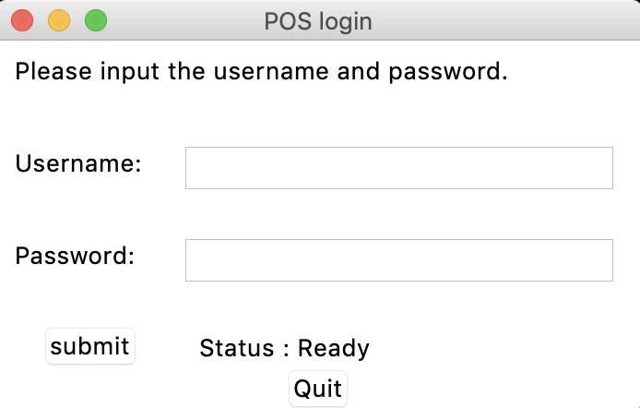

The above window will be showed and the user should login by their username and password.

And this below window will be prompted out

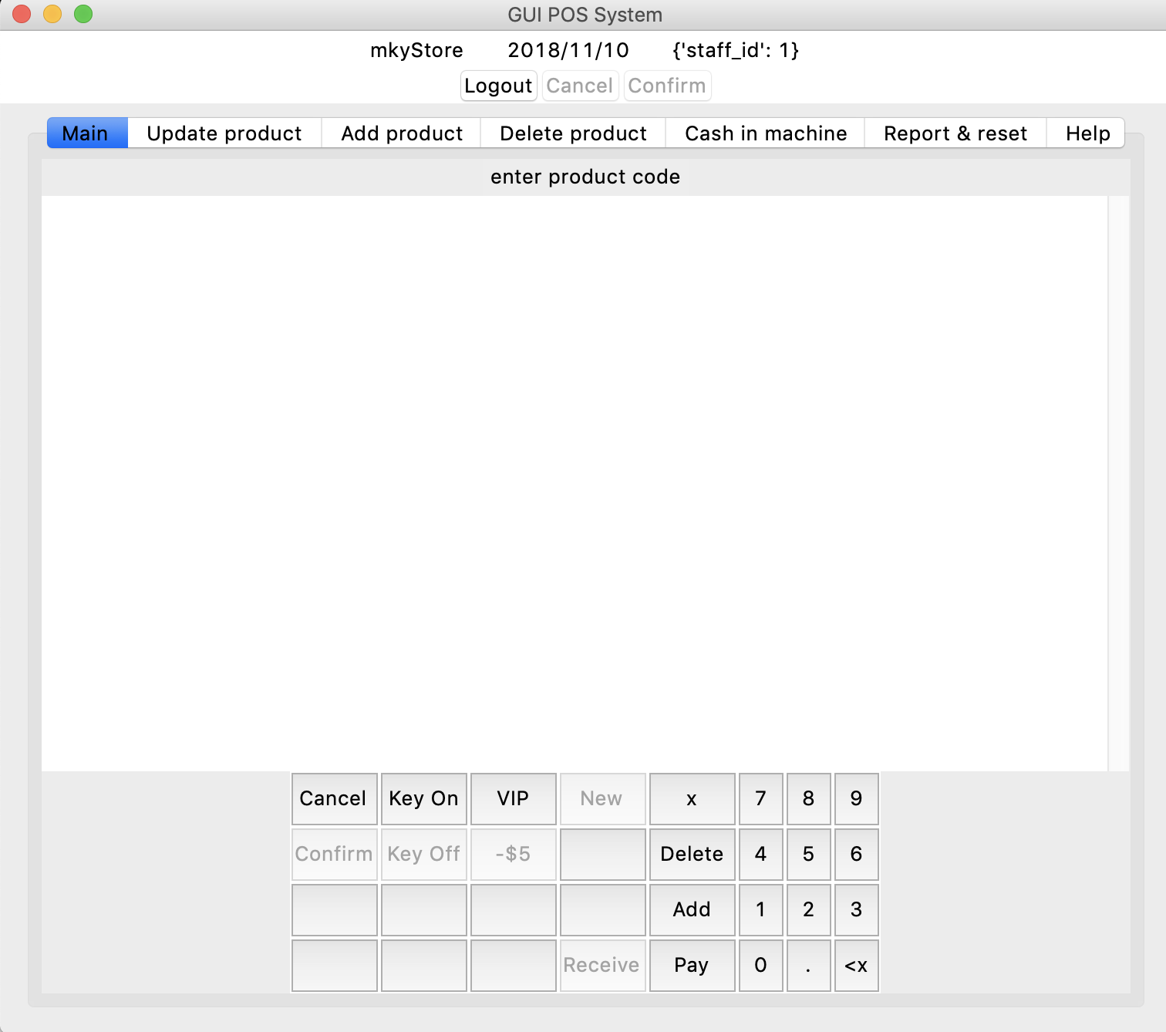

This is the main window of the POS system which allow user to use all the functions.

The main tab of the POS system allow staff to calculate how much the customer should pay, update the inventory, and print receipt.

## Add product

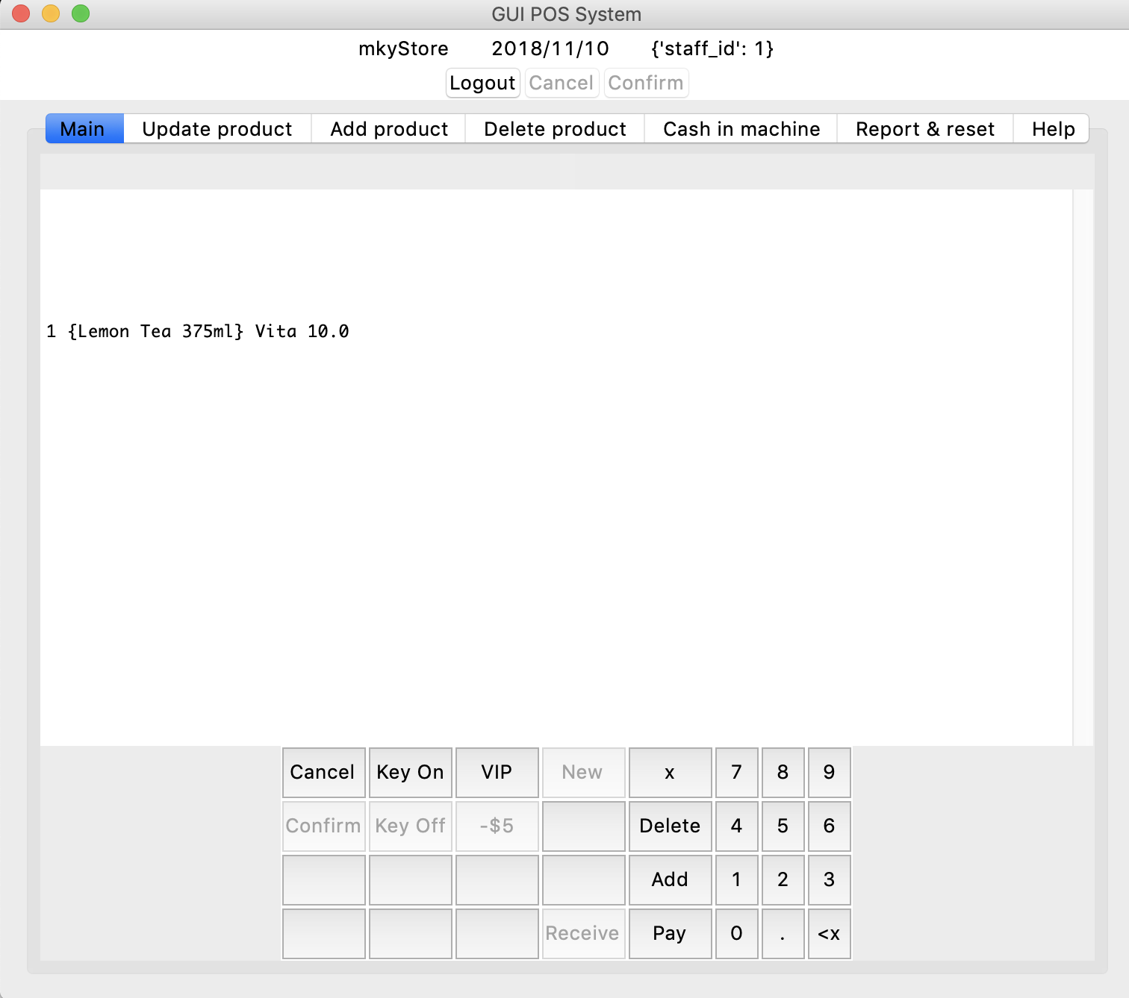

To add one product to the basket, the user need to input the product ID by using the virtual number pad on screen or click the Key On button and input by keyboard.

Then the user should click the Add button, and the product you add will be shown on screen.

To add more than one of the same products, the user should input the product ID, click x and type number of that type products. (e.g. 1x3, which means the customer would like to buy 3 products which product ID is 1)

## Delete product

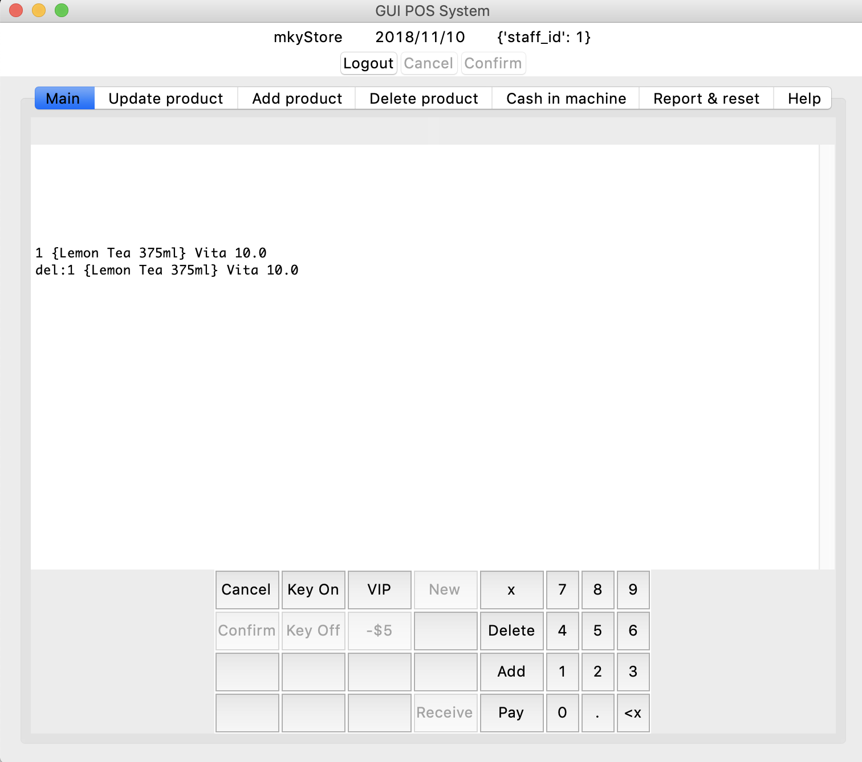

To delete product form the basket, the user need to input the product ID and click the Delete button. Moreover, the user could also delete more than one of the same products.

## Membership

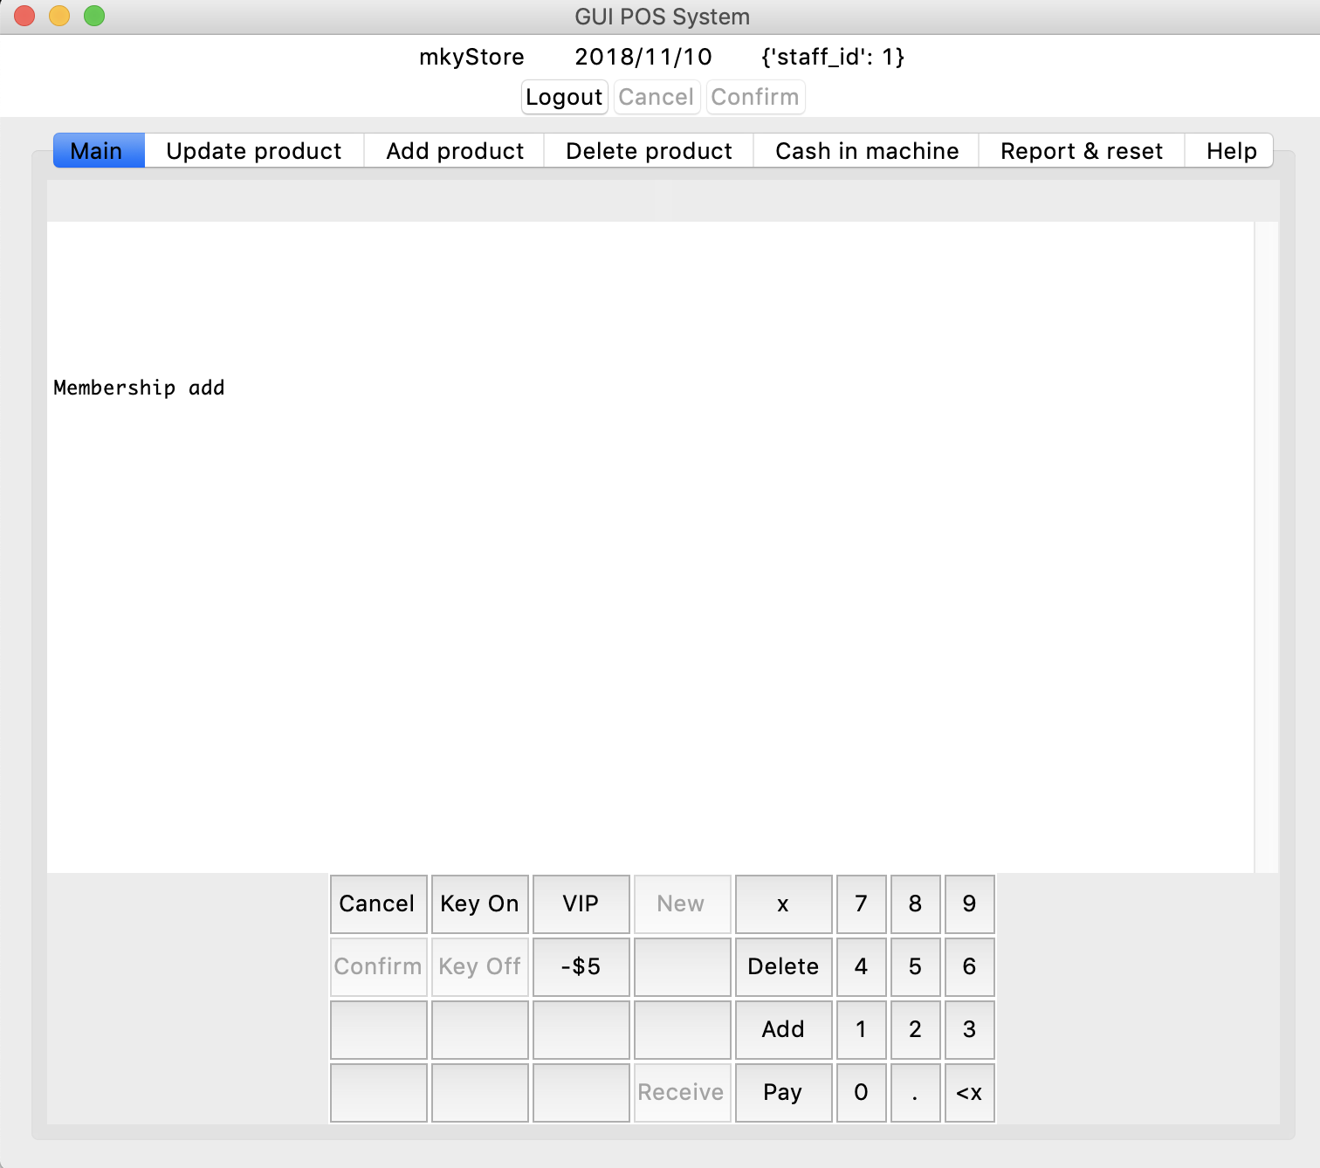

The staff can input membership’s phone number if the customer would like to, this allow customer to collect points when purchase ($1=1 point).

If the member has more than 200 points, the -$5 button will be lighted which allow customer to purchase 5 dollars cheaper.

## Payment by cash

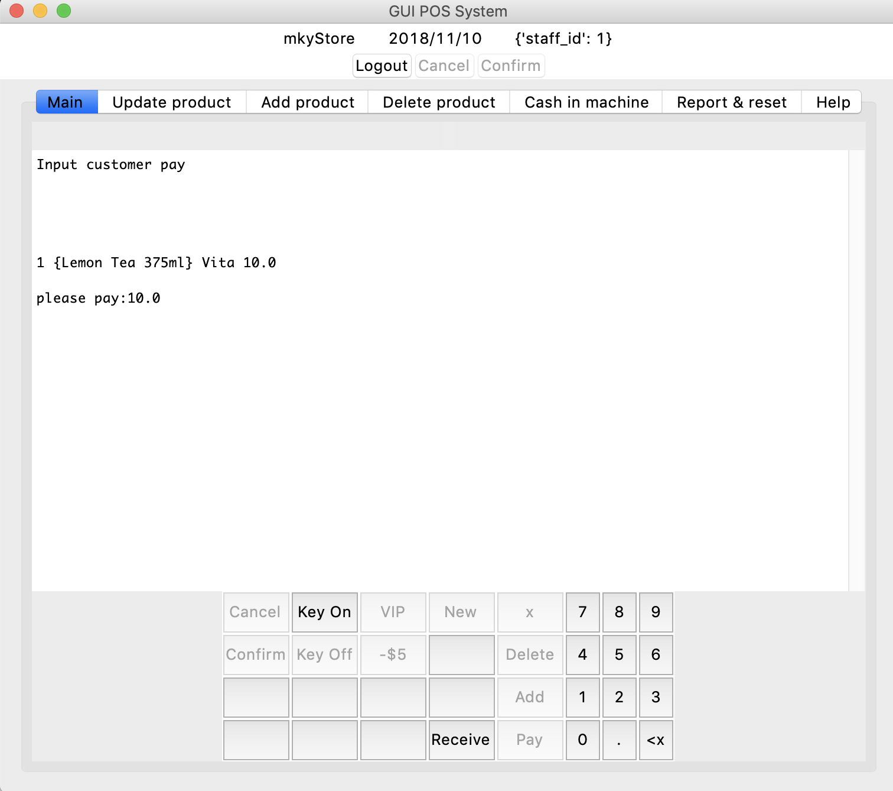

After press the pay button, the system will request the staff to input the amount customer paid.

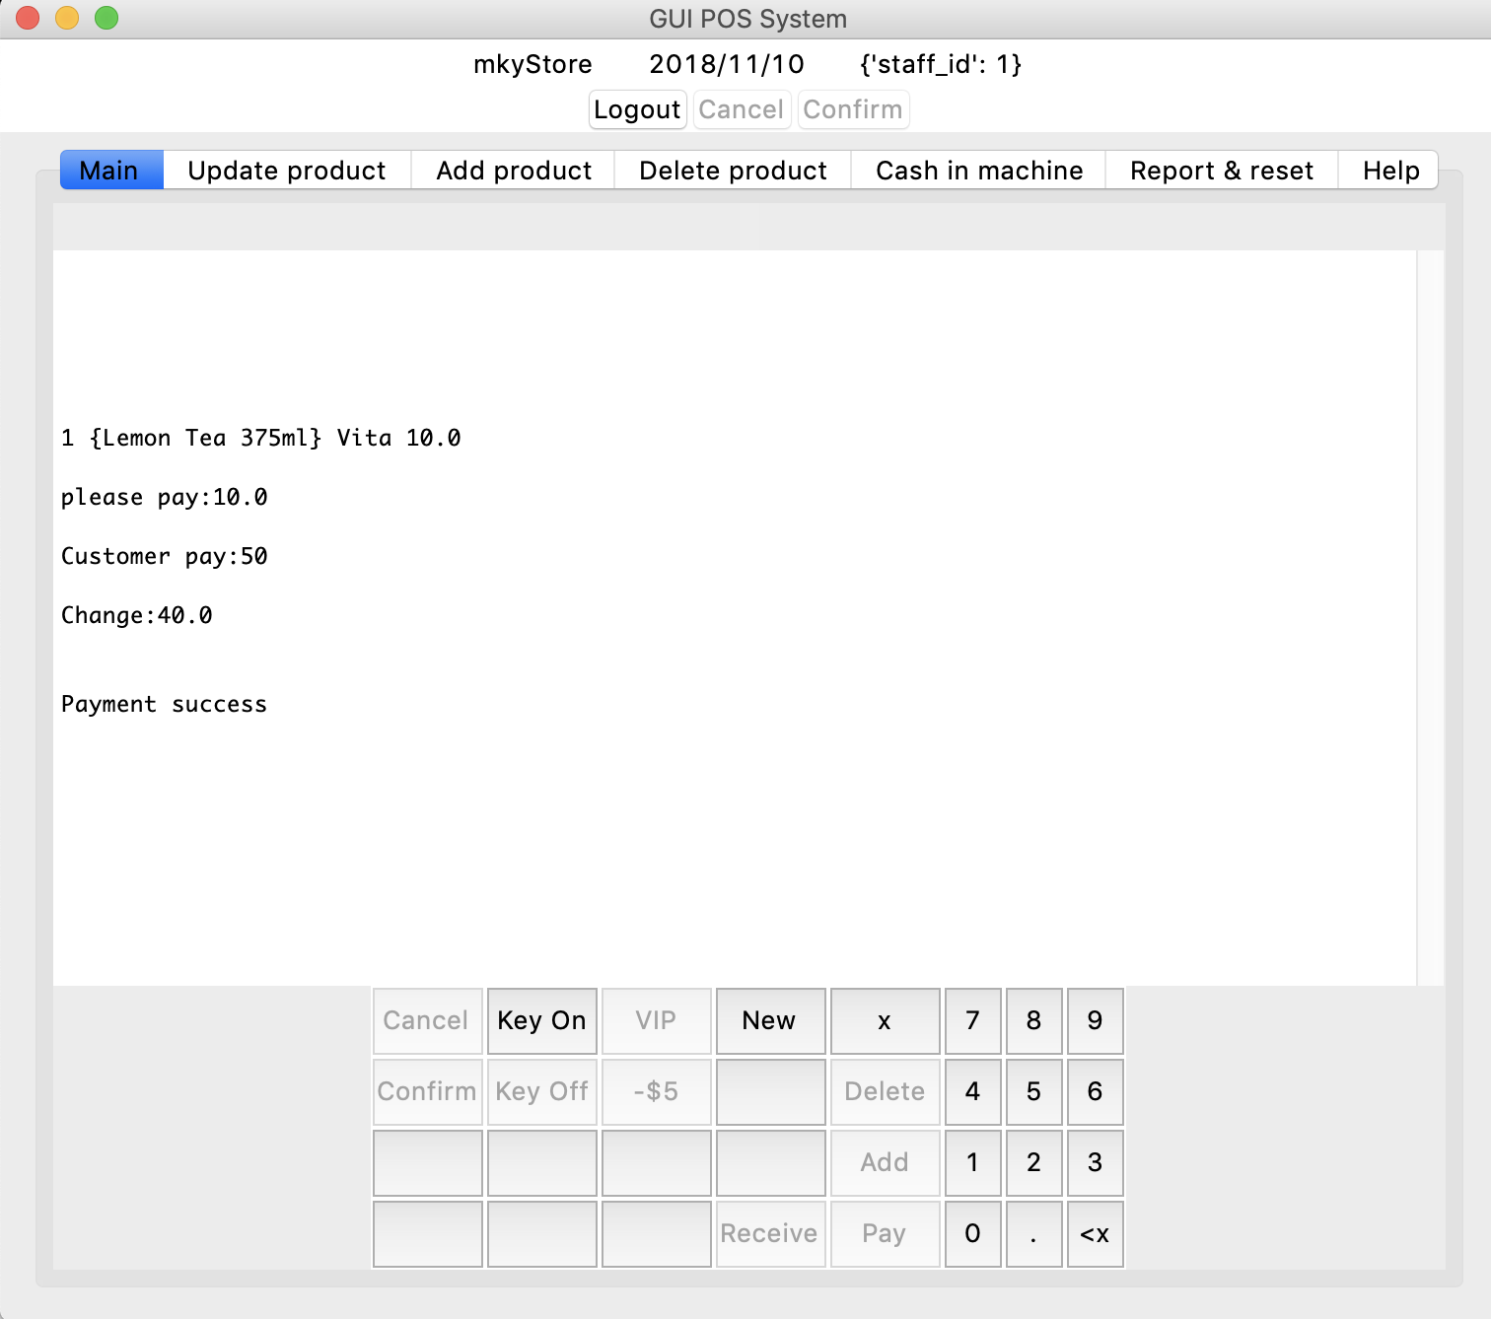

After the received button clicked, the system will show how much the staff should change.

Moreover, a receipt is also generated.

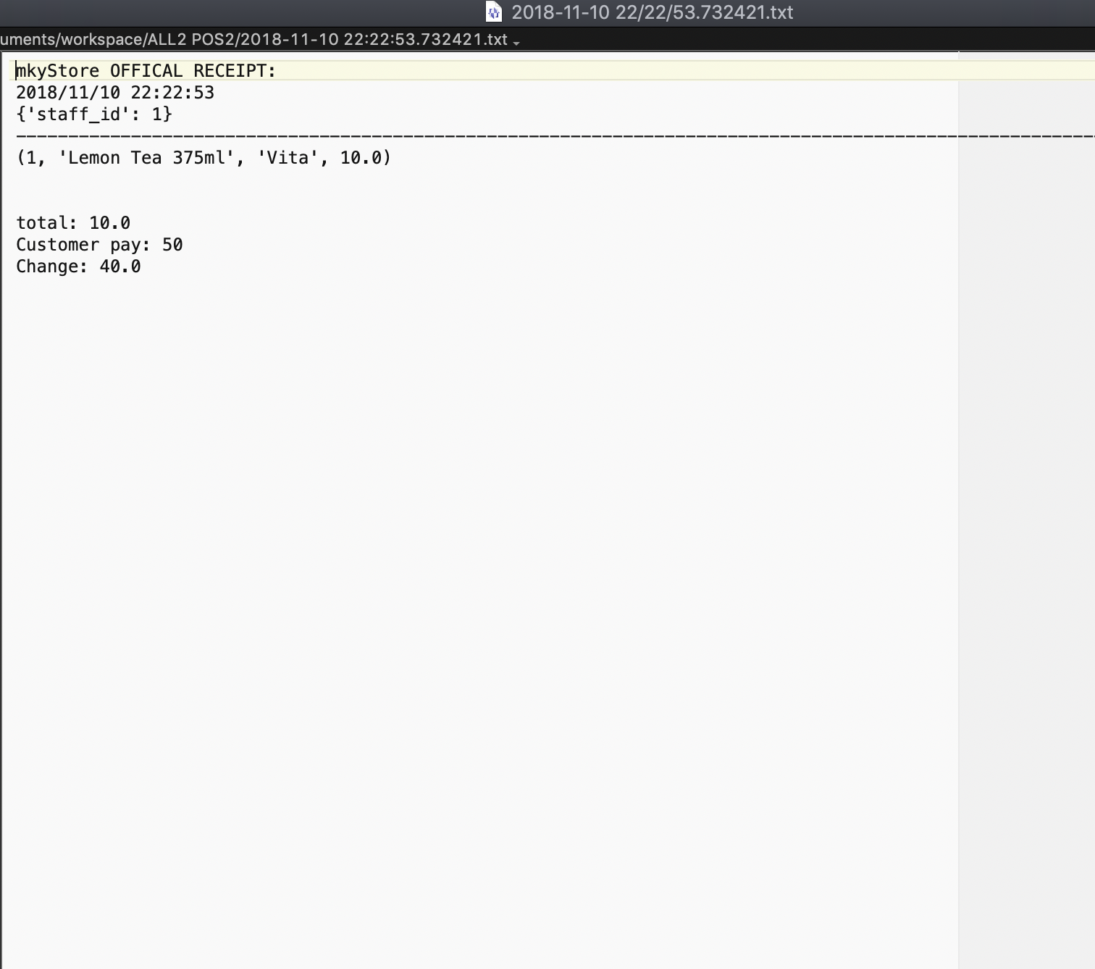

## Update product

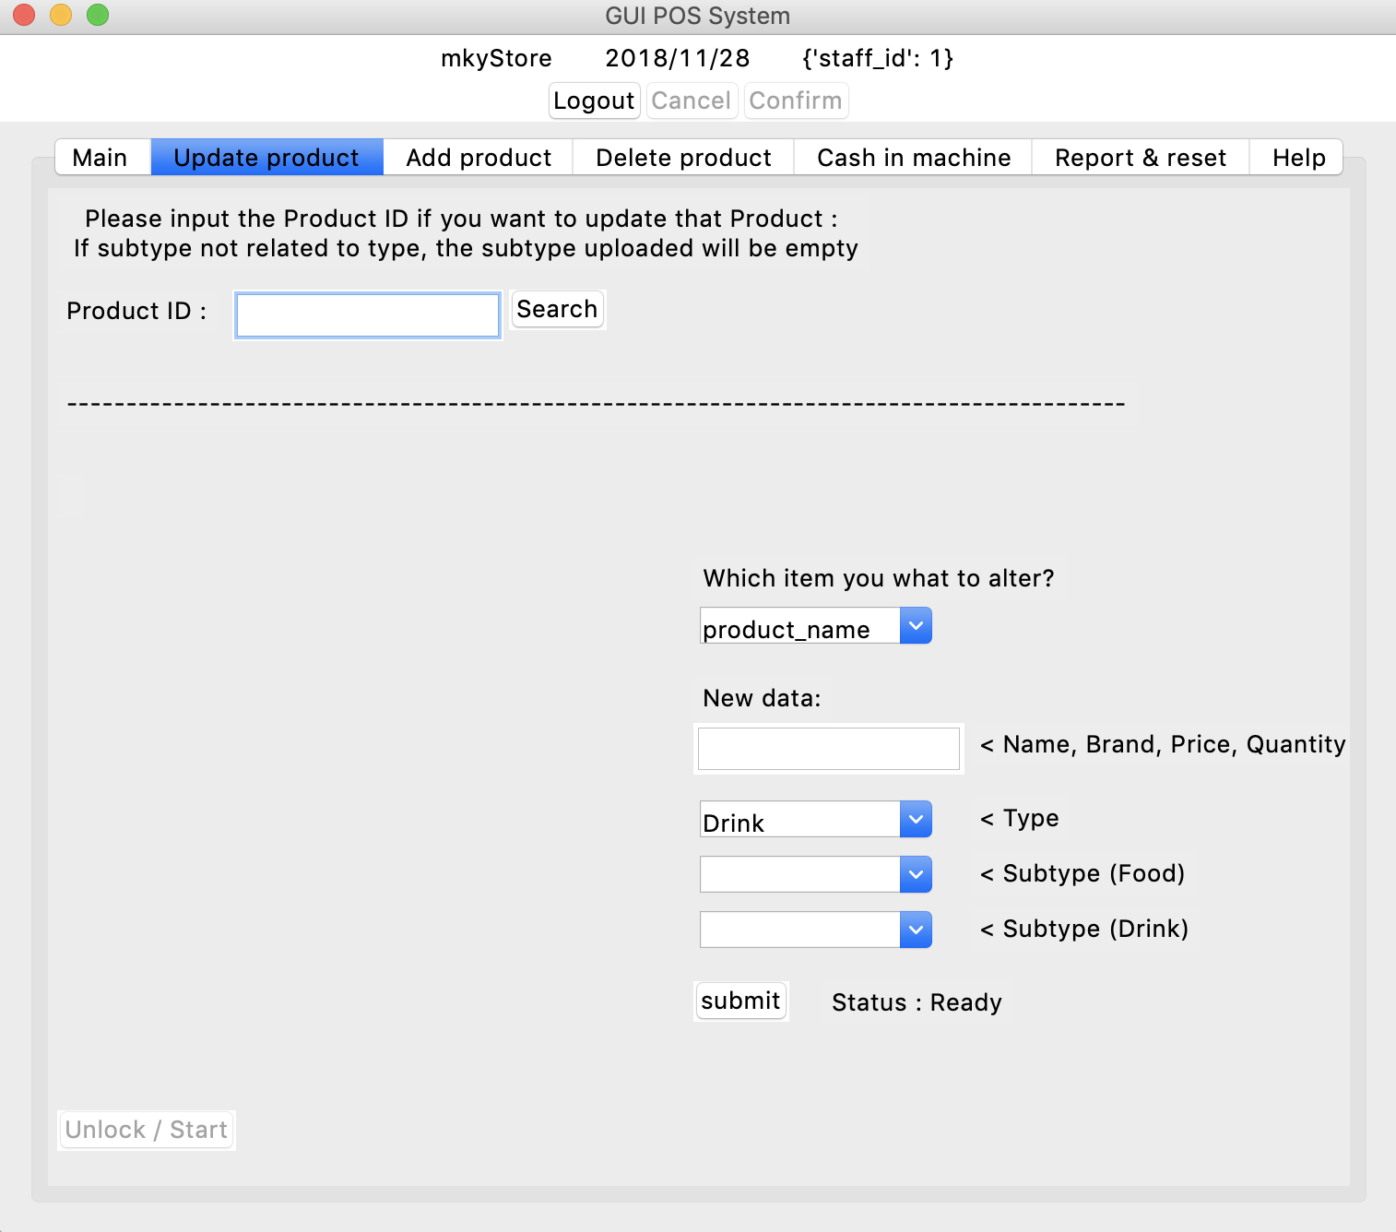

To update the product information, the user needs to input the Product ID first.

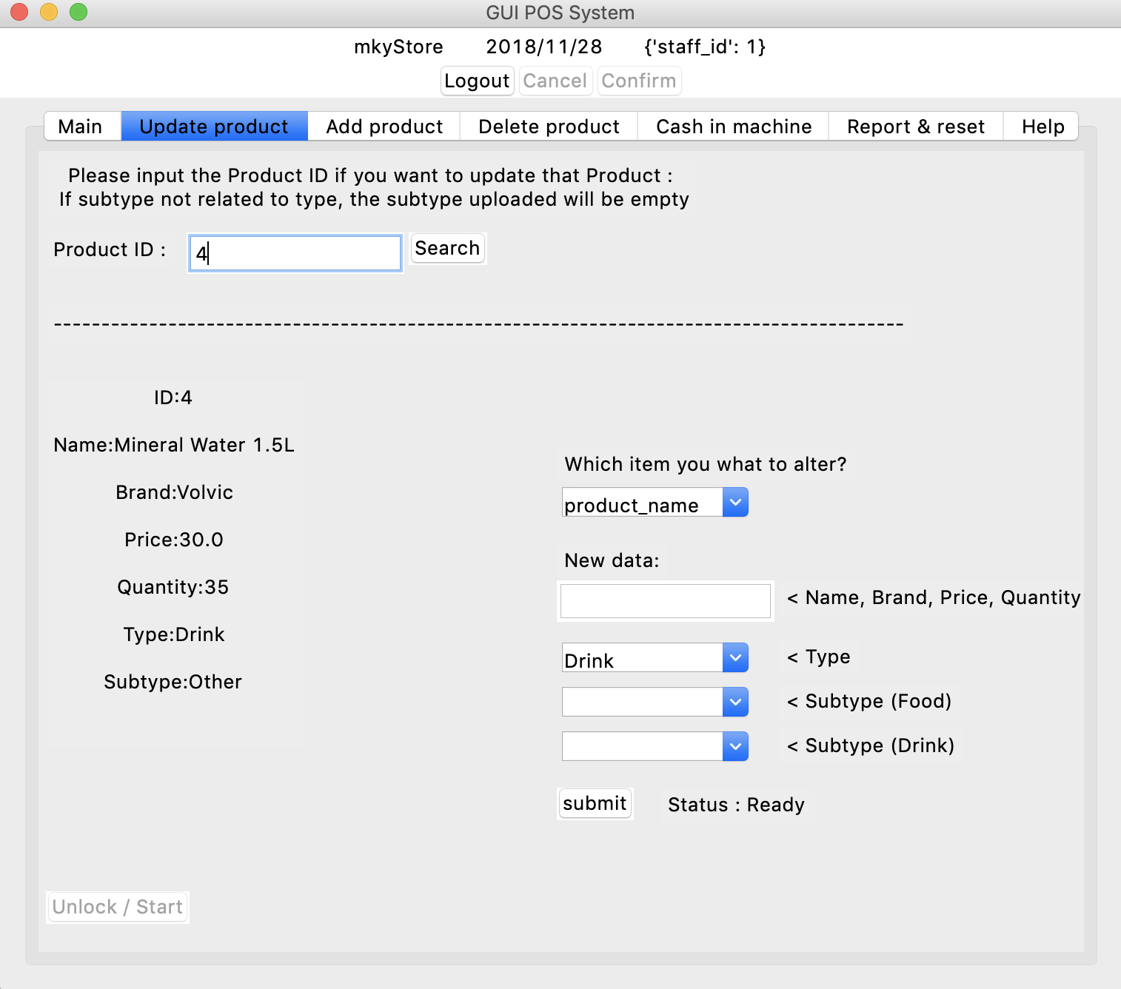

If the ID is valid, the product details will be shown and the user can input the updated information.

## Add product

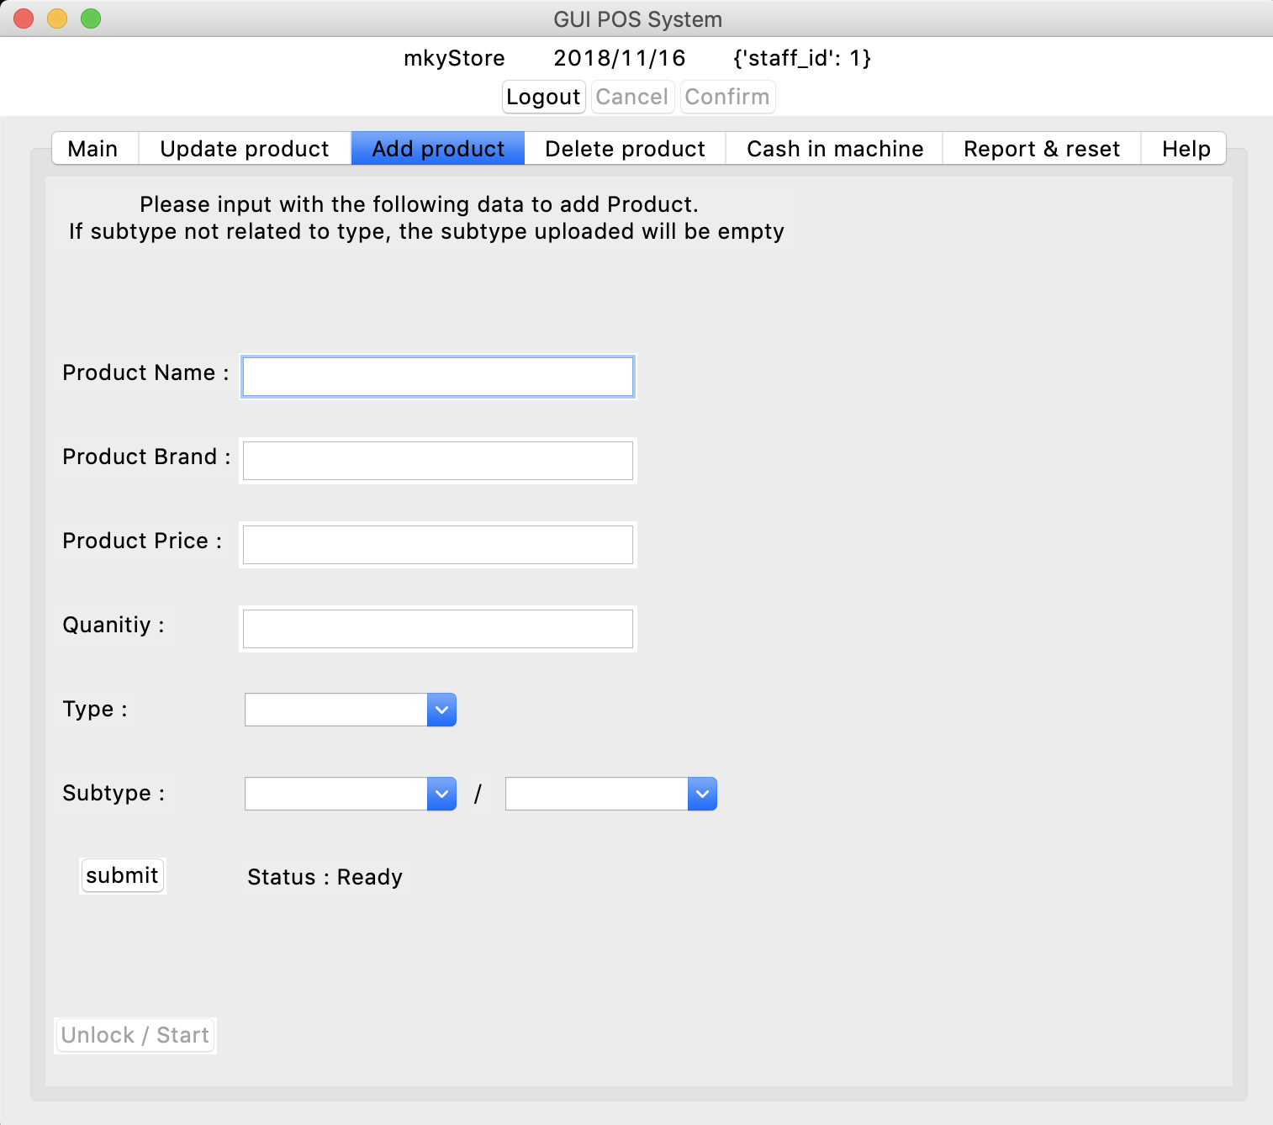

To update product, user need to input the information above and click the submit button.

## Delete product

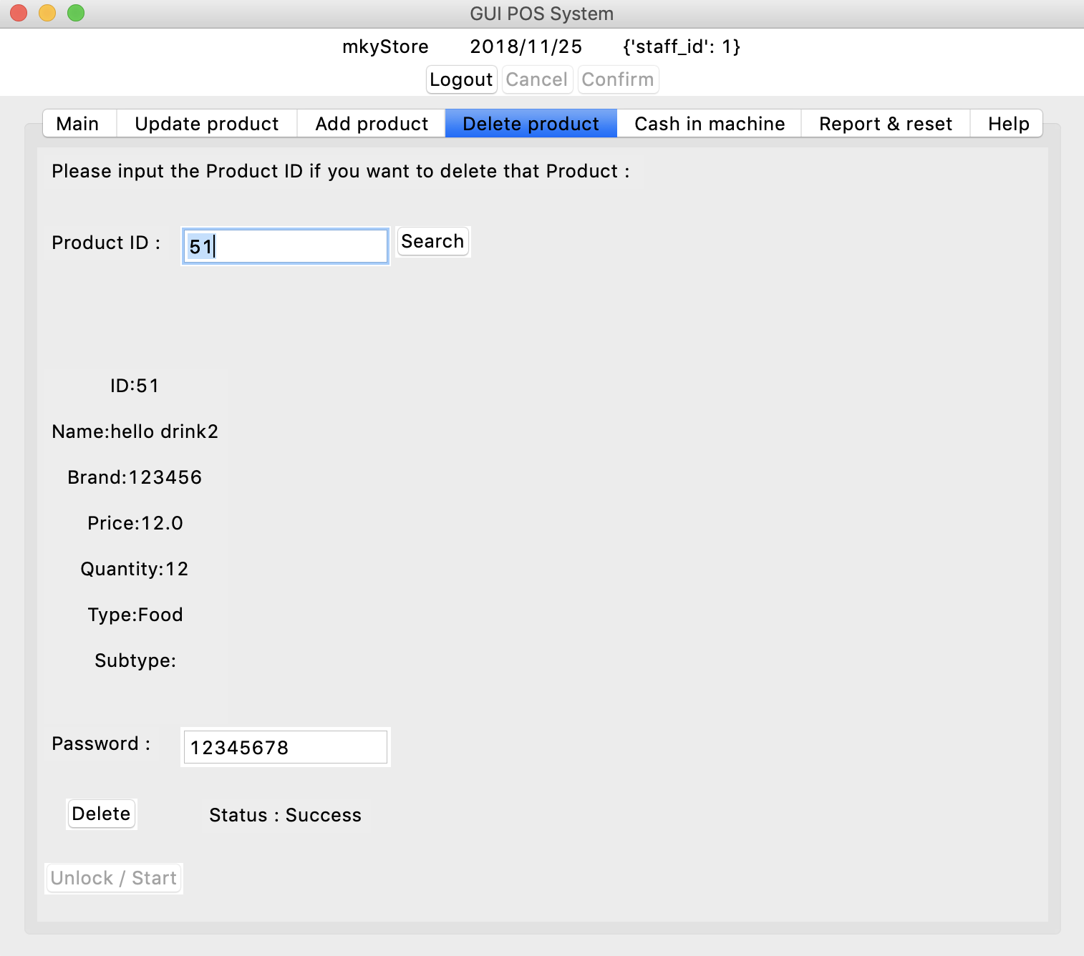

To delete the product data, just search the product ID, type the password and click the Delete button.

## Cash In Machine

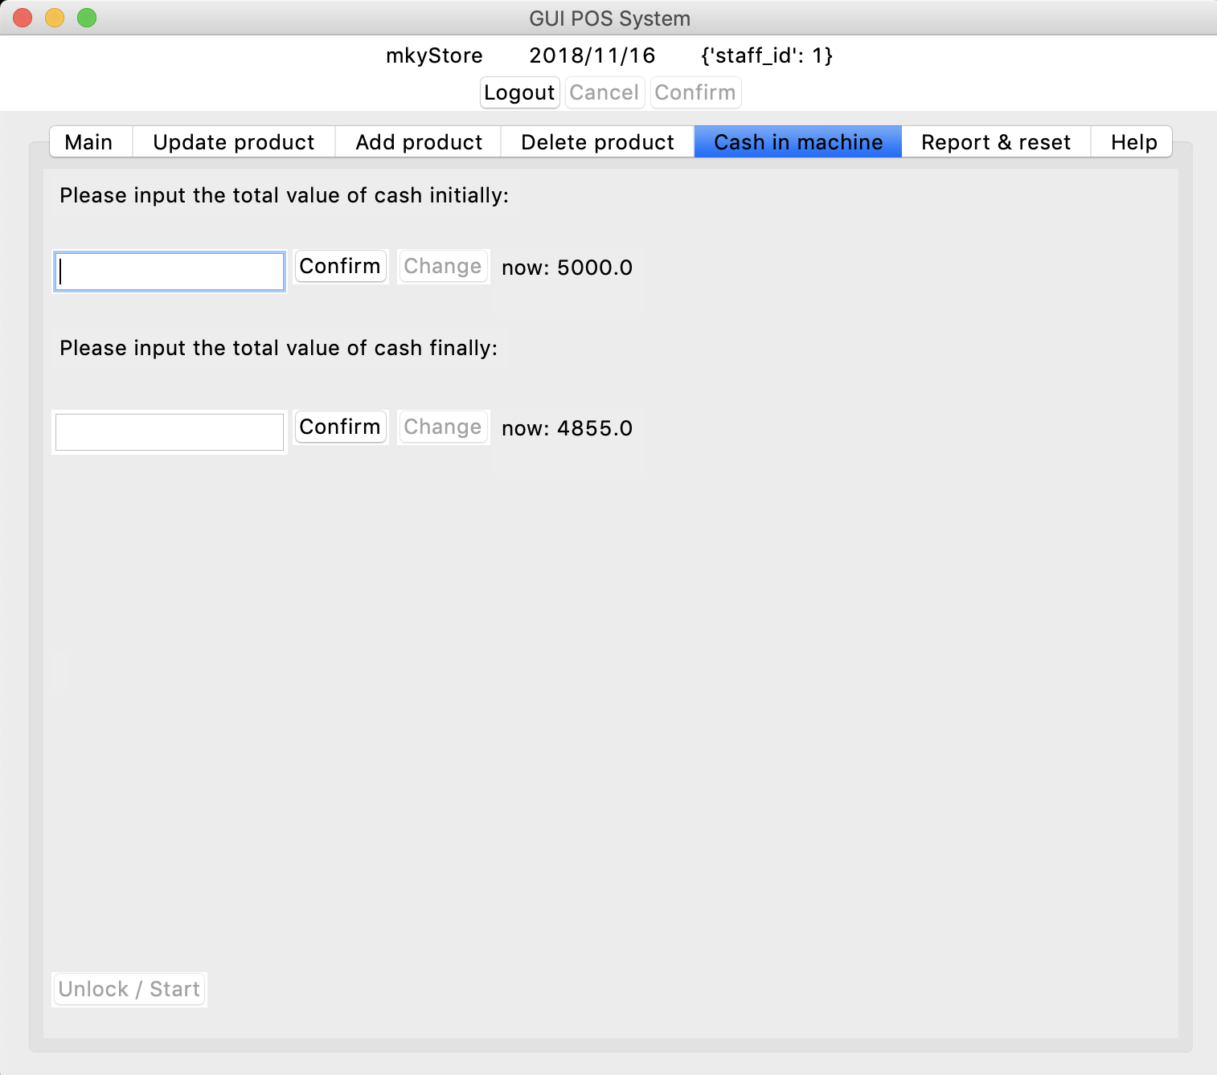

Just input the value, and the value will be saved to the data file.

## Report and Reset

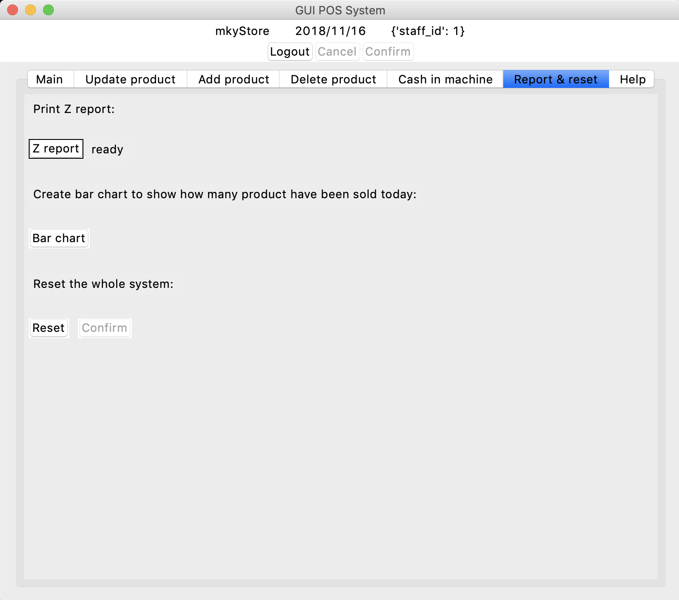

Just press the button and the report will be output or the data stored in data file will be reset.

## Z report

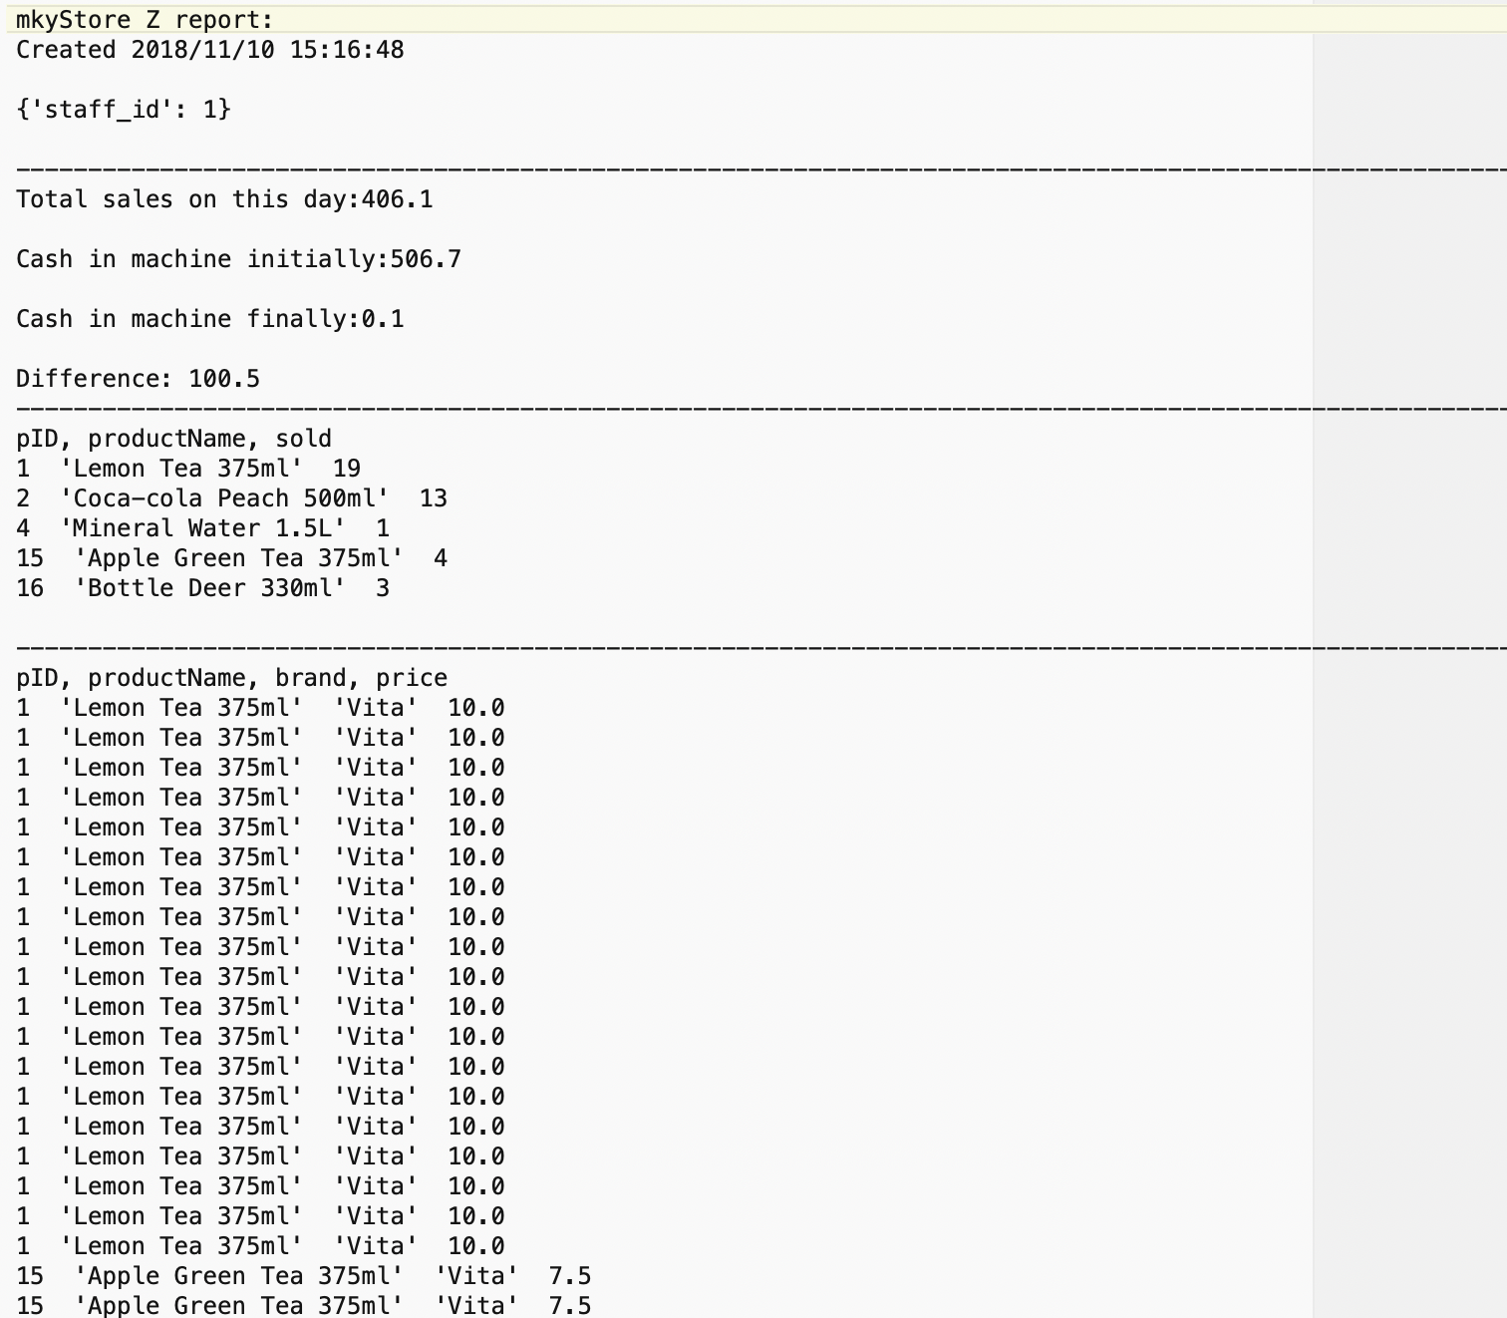

The Z report shows the products sold that day, how much that they earn and the difference between the cash when the store open and close.

## Bar chart

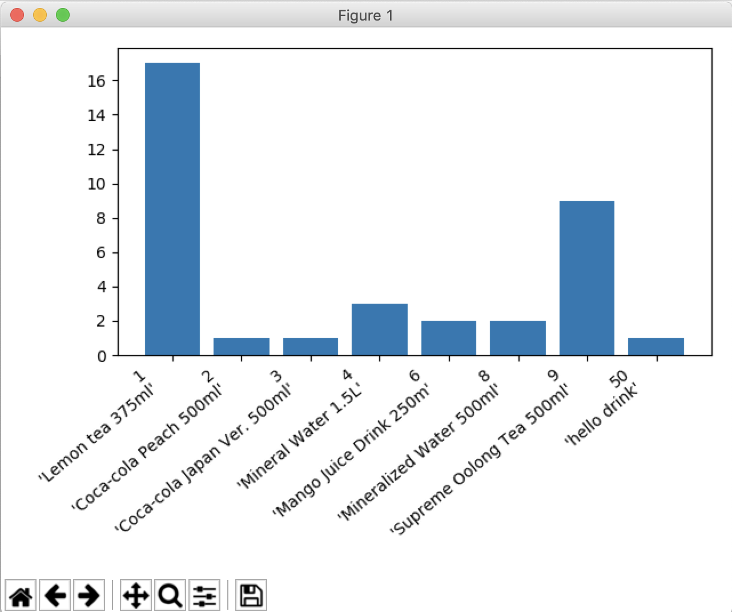

The bar chart shows the amounts of each products sold on one day.

## Logout

To logout just press the logout button on top of the window and the login screen will be prompt out.

# Testing

## login

|  |  |  |  |
| --- | --- | --- | --- |
| Input | Output | Description | Pass |
| Valid data (user name and password in database): |  | The POS system main program displayed successfully | Yes |
| Invalid data (password not in database): |  | Message of invalid data input is displayed | Yes |
| Invalid data (username not in database): |  | Message of invalid data input is displayed | Yes |

## Payment by cash

Add product

|  |  |  |  |
| --- | --- | --- | --- |
| Input | Output | Description | Pass |
| Valid data (add 1 product):  Input product ID 1 and press add button |  | The product information displayed on screen | Yes |
| Valid data (add more than 1 product):  Input product ID 1 x 3 and press add button |  | Three products information displayed on screen | Yes |
| Invalid data (invalid product ID):  Input product ID 1.1 x 3 and press add button |  | Message of invalid data input is displayed | Yes |
| Invalid data (invalid product ID):  Input product ID 90 and press add button |  | Message of invalid data input is displayed | Yes |
| No inventory:  Input product ID 3 and press add button |  | Message of no inventory is displayed | Yes |

Delete product

|  |  |  |  |
| --- | --- | --- | --- |
| Input | Output | Description | Pass |
| Delete the product in basket valid:  Original:  3 product ID 1 inserted  Input: delete product ID 1x2 |  | Two products delete displayed | Yes |
| Delete the product in basket invalid:  Original:  3 product ID 1 inserted  Input: delete product ID 1x5 |  | All three products are deleted with error message displayed | Yes |
| Invalid product ID inputted |  | Error message displayed | Yes |

Add membership

|  |  |  |  |
| --- | --- | --- | --- |
| Input | Output | Description | Pass |
| Valid: input phone number 43215345 |  | Message of valid input displayed | Yes |
| Valid: input phone number 87654321 |  | This member owned points >=200,state of  -$5 button become normal | Yes |
| Invalid:  Input 11.2345x3 |  | Message of invalid input displayed | Yes |
| Invalid:  Input 11.2 |  | Message of invalid input displayed | Yes |

Membership discount

|  |  |  |  |
| --- | --- | --- | --- |
| Input | Output | Description | Pass |
| Press -$5 button  (membership phone number: 87654321, original points:300) |  | The discount message displayed and the points in database decreased by 200 | Yes |

Payment by cash

|  |  |  |  |
| --- | --- | --- | --- |
| Input | Output | Description | Pass |
| Valid data    Original quantity of lemon tea:48  Original quantity of coke:7 |  | Database update successfully | Yes |
| Customer pay not enough  Should pay: $10  Customer pay: $5 |  | Error message displayed and tell the staff to input again | Yes |

Cancel button

|  |  |  |  |
| --- | --- | --- | --- |
| Input | Output | Description | Pass |
|  |  | The text shown in POS cleared | Yes |

## Update product information in database

|  |  |  |  |
| --- | --- | --- | --- |
| Input | Output | Description | Pass |
| Valid: Update product name to ‘x’ |  | The data updated and stored to database | Yes |
| Valid: Update product band to ‘prezi’ |  | The data updated and stored to database | Yes |
| Valid: Update price to 12.6 |  | The data updated and stored to database | Yes |
| Valid: Update quantity to 10 |  | The data updated and stored to database | Yes |
| Valid: update type to food |  | The data updated and stored to database  and subtype field cleared | Yes |
| Valid: update subtype to other |  | The data updated and stored to database | Yes |
| Invalid: search product ID ‘a’ |  | Error message shown | Yes |
| Invalid: update price to a |  | Error message shown | Yes |
| Invalid: update quantity to a |  | Error message shown | Yes |
| Invalid: update subtype to a not a choice of that field |  | The subtype field become empty | Yes |
| Invalid: update subtype to a not a choice of that field |  | The subtype field become empty | Yes |

## Add new product to database

|  |  |  |
| --- | --- | --- |
| Input | Output | Pass |
| Valid | Database updated | Yes |
| Invalid price ‘a’ inputted | Error message displayed | Yes |
| Invalid price -10 inputted | Error message displayed | Yes |
| Invalid quantity ‘a’ inputted | Error message displayed | Yes |
| Invalid quantity -12 inputted | Error message displayed | Yes |
| Input subtype which is not in that type | Data is inputted to database but subtype field is empty | Yes |

## Delete product data in database

|  |  |  |  |
| --- | --- | --- | --- |
| Input | Output | Description | Pass |
| Input product ID 51 |  | System find the product and allow user to delete from database  After pressed the delete button, the data is deleted from database and deleteReport.txt updated | Yes |
| Input invalid product ID ‘gegre’ |  | Error message  shown | Yes |
| Input invalid password |  | Error message  shown | Yes |

## Cash in machine

Initially

|  |  |  |  |
| --- | --- | --- | --- |
| Input | Output | Description | Pass |
| Valid: 506.7 |  | Data saved to text file | Yes |
| Invalid: -123 |  | Error message shown | Yes |
| Invalid: a |  | Error message shown | Yes |

Finally

|  |  |  |  |
| --- | --- | --- | --- |
| Input | Output | Description | Pass |
| Valid: 0.1 |  | Data saved to text file | Yes |
| Invalid: -0.1 |  | Error message shown | Yes |
| Invalid: afva |  | Error message shown | Yes |

## Buttons

|  |  |  |  |
| --- | --- | --- | --- |
| Input | Output | Description | Pass |
| Z report |  | Z report exported | Yes |
| Bar chart |  | Bar chart shown | Yes |
| Quit button | The pos system quit | / | Yes |
| Reset |  | The datafile all reset | Yes |
| KeyOn | The numbers in main can now inputted by keyboard    Also all other input fields in other pages change to disable | / | Yes |
| KeyOff or Unlock / Start | The numbers in main can only be inputted by virtual keypad on screen  Also Also all other input fields in other pages change back to normal | / | Yes |
| add product ID 1 to basket and click Cancel | The screen cleared | / | Yes |

## Logout

|  |  |  |  |
| --- | --- | --- | --- |
| Input | Output | Description | Pass |
| Click logout and click confirm |  | / | Yes |

# Limitation of our POS system

1. If the user accidently quit the system, the data such as inventory of the system may not be same as reality. Due to the fact that the inventory is change during adding or deleting product to the basket, if the system suddenly quit at that moment, the inventory will be changed but the purchase process is not completed.
2. If customer would like to refund, the system could not register the record as there are no refund function.

1. The system only received cash.
2. If the product is deleted from database, the z report can still show the deleted products sold, but can’t count how many of that products sold.

# Introduction to The Website

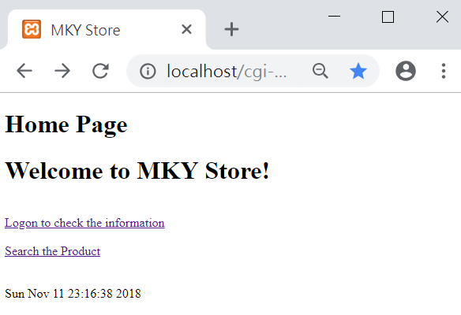

The Website Include the following features for Customer:

* Searching and Compare product price in different category
* Customer register
* Login
  + Check personal information
  + Update personal information

# How to use the Website

## Searching and Comparing

Click the hyperlink- ‘Search the Product’ on home page, user can Search by Product Name, by category, by Brand, by price or by Product ID.

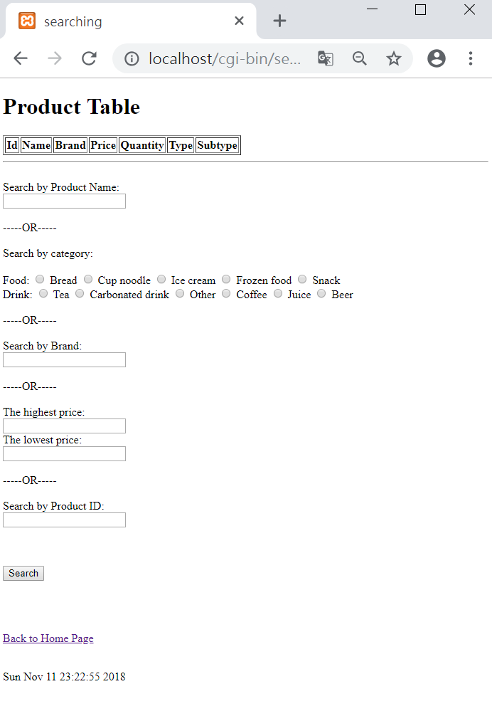

## Logon Page

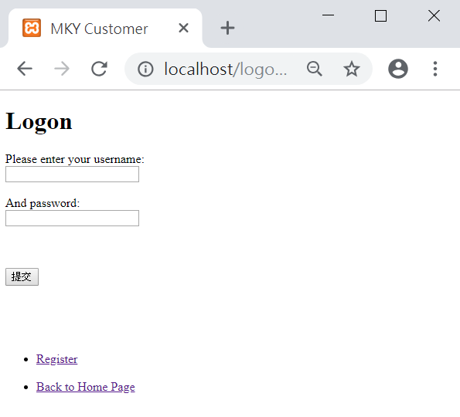

After click the hyperlink- ‘Logon to check the information’ on home page, user can input the username and password to logon. Also, user can click the hyperlink- ‘Register’ to register.

## Register Page

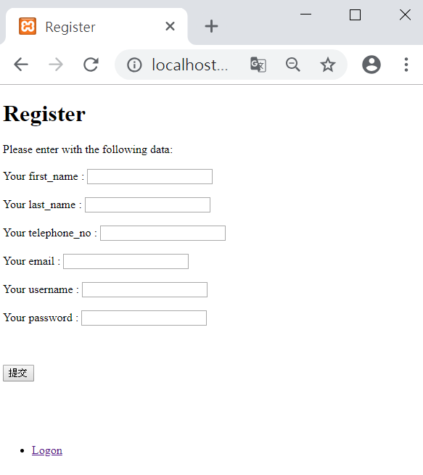

To register, user need to input the information above and click the submit button.

## Personal information

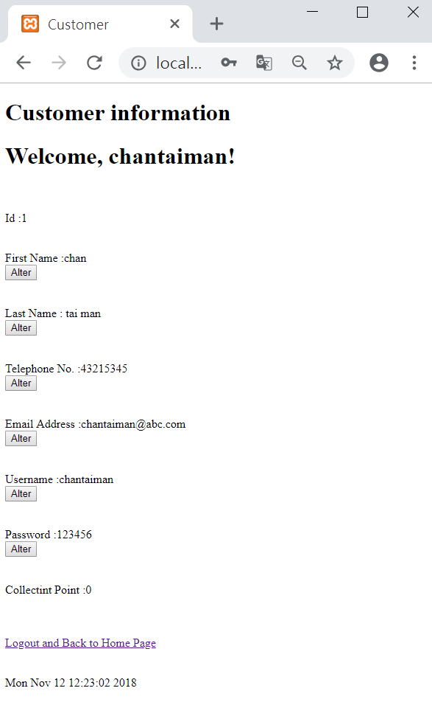

After logon, user can check the information as well as above. If user want to update the information, he/she can click the ‘Alter Button’ which is related.

## Alter information

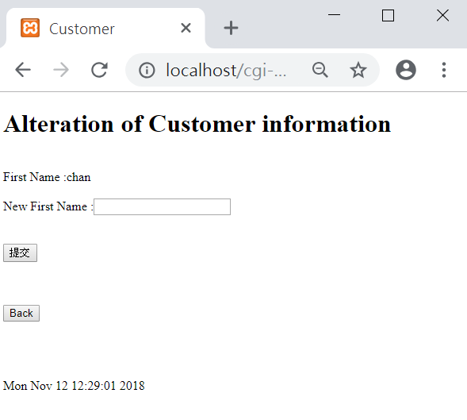

After clicking the ‘Alter Button’, user can input the new data.

# Website Testing

## Register

|  |  |  |
| --- | --- | --- |
| Input | Output | Pass |
| Valid data | The system displayed successfully | Yes |
| Invalid data (the telephone_no is already used): | Message of invalid data input is displayed | Yes |
| Invalid data (the telephone_no is incorrect): | Message of invalid data input is displayed | Yes |
| Invalid data (the telephone_no is incorrect): | Message of invalid data input is displayed | Yes |

|  |  |  |
| --- | --- | --- |
| Invalid data (the email is already used): | Message of invalid data input is displayed | Yes |
| Invalid data (the username is already used): | Message of invalid data input is displayed | Yes |

|  |  |  |
| --- | --- | --- |
| Invalid data (Missing data): | Message of invalid data input is displayed | Yes |

## logon

|  |  |  |
| --- | --- | --- |
| Input | Output | Pass |
| Valid data (user name and password in database): | The system displayed successfully | Yes |
| Invalid data (password not in database): | Message of invalid data input is displayed | Yes |
| Invalid data (username not in database): | Message of invalid data input is displayed | Yes |
| Invalid data (empty username and password): | Message of invalid data input is displayed | Yes |

## Alteration

|  |  |  |
| --- | --- | --- |
| Input | Output | Pass |
| Valid data | The system displayed successfully | Yes |
| Invalid data (the telephone_no is already used): | Message of invalid data input is displayed | Yes |
| Invalid data (the telephone_no is incorrect): | Message of invalid data input is displayed | Yes |
| Invalid data (the telephone_no is incorrect): | Message of invalid data input is displayed | Yes |
| Invalid data (the email is already used): | Message of invalid data input is displayed | Yes |
| Invalid data (the username is already used): | Message of invalid data input is displayed | Yes |

## Searching

|  |  |  |
| --- | --- | --- |
| Input | Output | Pass |
| Valid data: | The system displayed successfully | Yes |
| Valid data (in multi-area): | The system displayed the data which is match either one of the conditions successfully | Yes |
| Invalid data (highest price and lowest price are reverse): | The system will reverse two value automatically | Yes |
| Invalid data (incorrect data): | The system cannot find the data to show. | Yes |

# Limitation of our website

1. It cannot confirm whether the email or telephone number is valid.
2. It will drop the data which the user input if its length is longer than the database setting
3. It can only use the username to logon.
4. User can input a space as a data while it is not good

# List of Reference

Fortress (n.d.) *Dell XPS 15-9570 notebook* [online] available from

<https://www.fortress.com.hk/en/product/xps15-9570-notebook/p/BP_11804952> [13 November 2018]

Python Software Foundation (2018) *The Python Standard Library* [online] available from

<https://docs.python.org/3.6/library/index.html> [5 November 2018]

Tutorials Point (2018) *Python – Tkinter Button* [online] available from

<https://www.tutorialspoint.com/python/tk_button.htm> [10 November 2018]

Visual Program (n.d.) *UML Class Diagram Tutorial* [online] available from

<https://www.visual-paradigm.com/guide/uml-unified-modeling-language/uml-class-diagram-tutorial/> [11 November 2018]